Project / Event

A Memorable Partnership Visit with Hope and Healing!

CHAL Hosts Hope and Healing Canada for a Meaningful Exchange

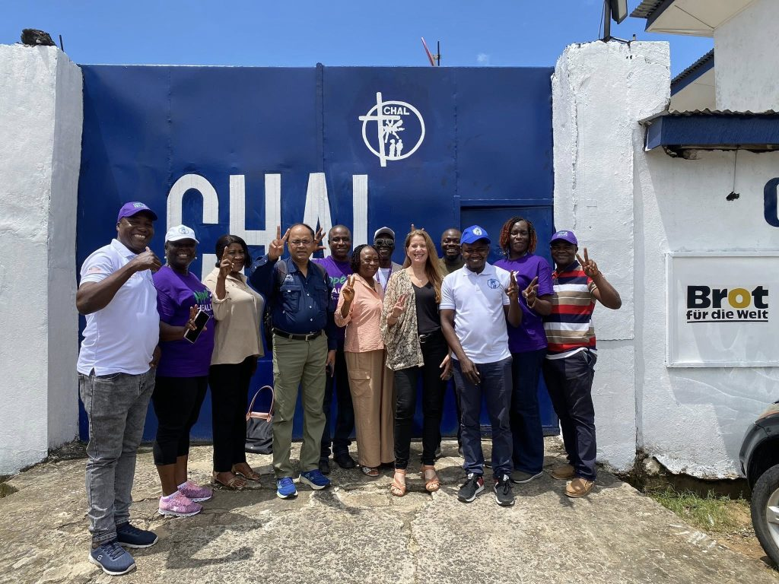
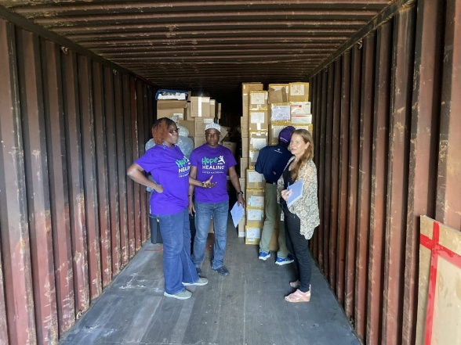
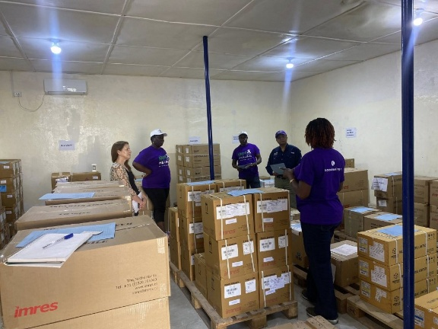
The Christian Health Association of Liberia (CHAL) had the distinct pleasure of welcoming our esteemed guests from Hope and Healing Canada for a comprehensive tour of our facilities. This visit offered a unique opportunity for learning, collaboration, and shared insights, bringing together partners committed to improving health outcomes across Liberia.

During the tour, our guests were guided through CHAL’s offices, staff teams, warehouse, and operational units, gaining a firsthand understanding of the work we do daily to strengthen Liberia’s healthcare system. It was an enriching experience for both sides, as insightful presentations and discussions highlighted our ongoing projects, challenges, and achievements. The exchange went beyond observation — it was a mutual learning opportunity. Our visitors shared global perspectives, best practices, and innovative strategies in health management, inspiring CHAL staff and fostering ideas for enhanced service delivery. This knowledge-sharing session underscored the importance of international collaboration in addressing health challenges and advancing community well-being.
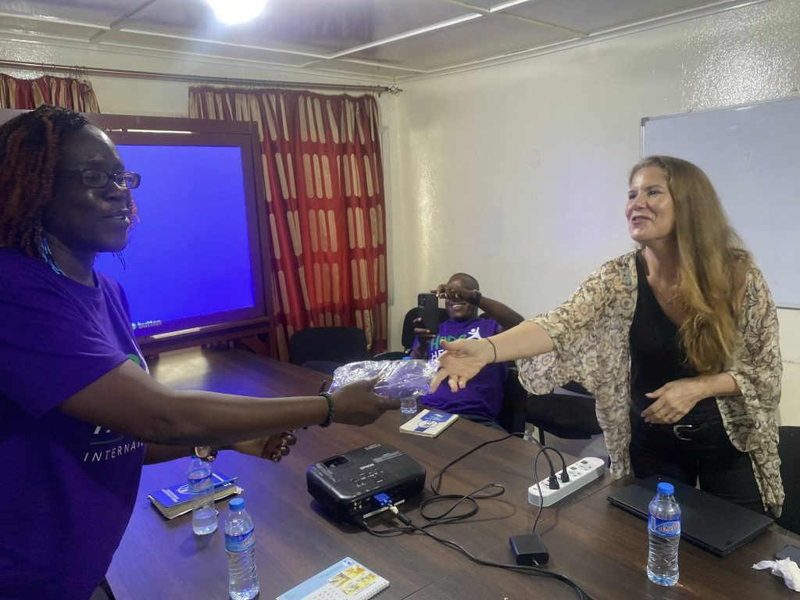
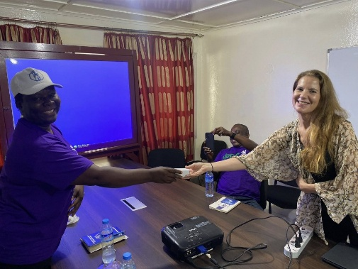
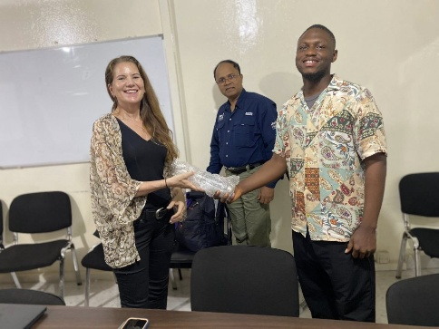
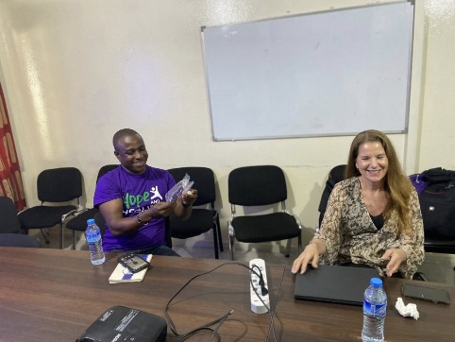

To cap off the tour, several of our dedicated staff members were honored with thoughtful gifts, recognizing their hard work, dedication, and unwavering commitment to improving health services across Liberia. These gestures reflected both appreciation and encouragement, reinforcing the values of teamwork, compassion, and excellence that drive CHAL’s mission. we were honored to host a special engagement meeting with our esteemed guests from Hope and Healing, an international NGO committed to transforming the lives of children.
During the session, CHAL shared an overview of our ongoing work, while our guests highlighted their impactful programs, which support children through both cash and in-kind contributions, including medications, food, and essential care.
Their work spans five main domains, with a strong emphasis on:
- Health
- Education for children with disabilities
- Family and livelihoods
- Building self-value and confidence
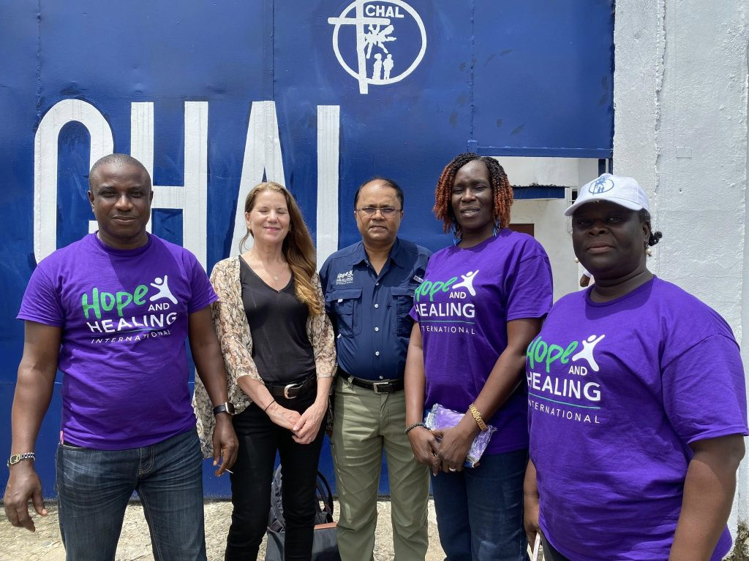
It was truly inspiring to exchange ideas and explore opportunities to work together in creating a brighter future for children in need.

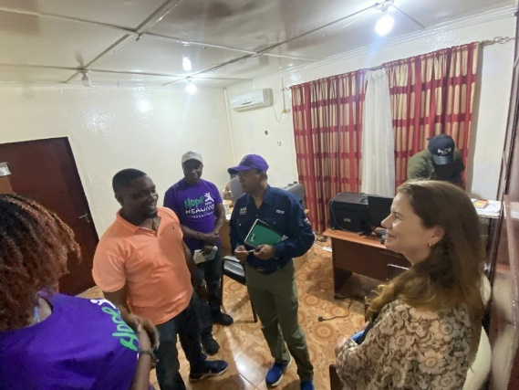
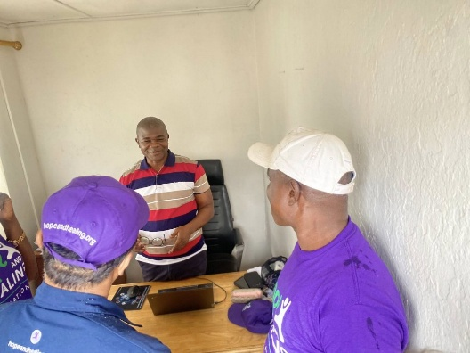
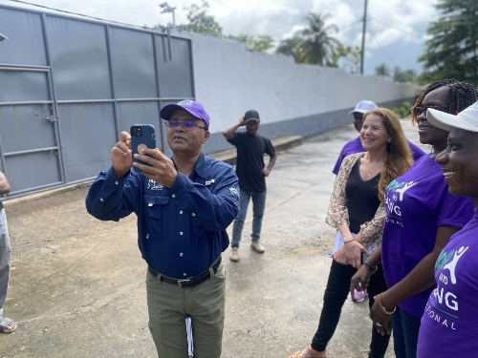
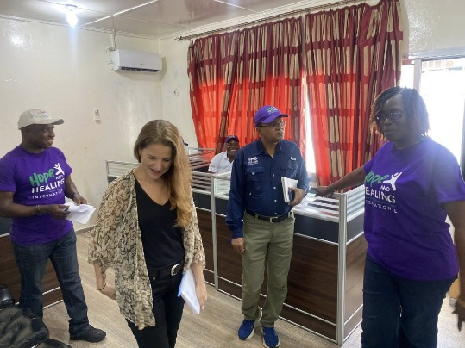
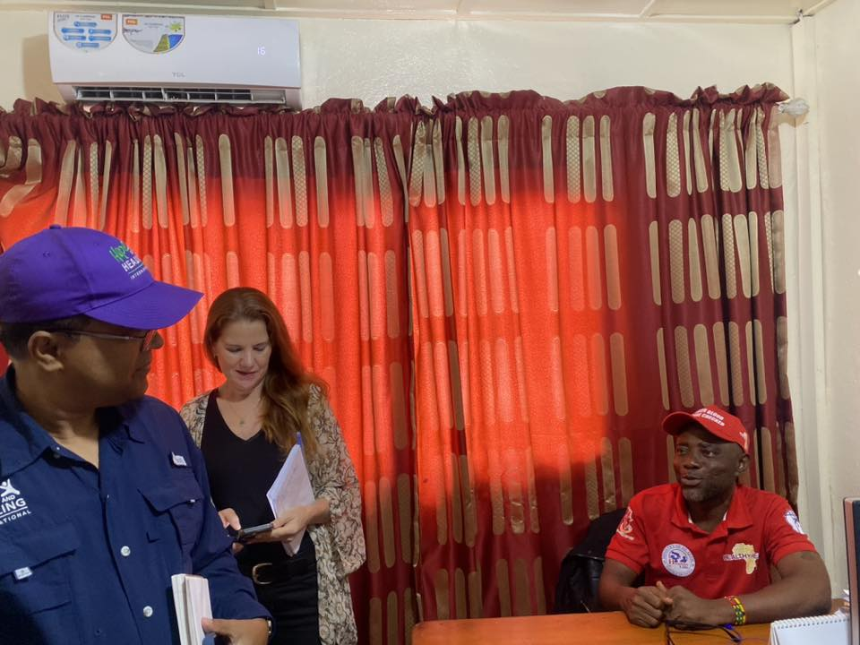
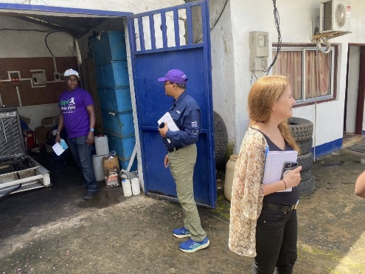
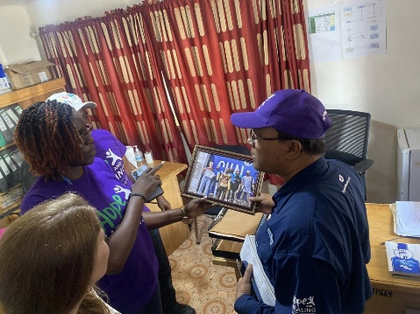
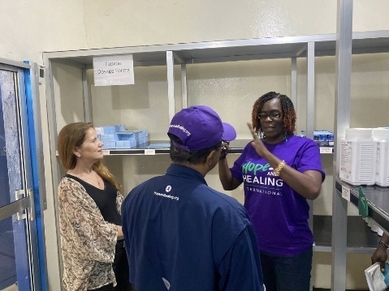
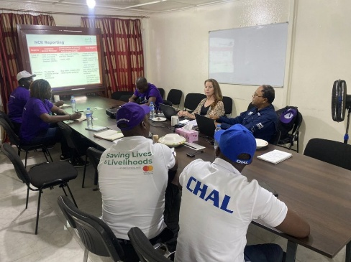
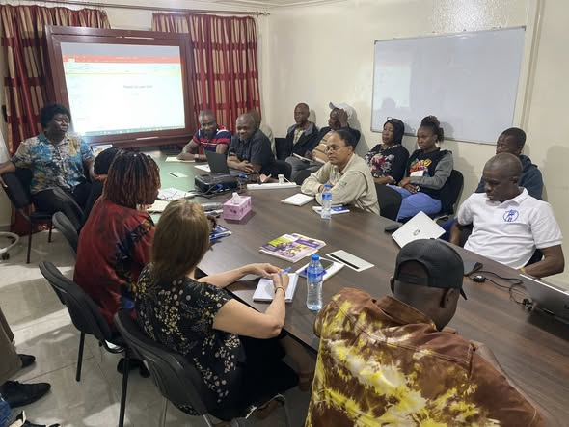
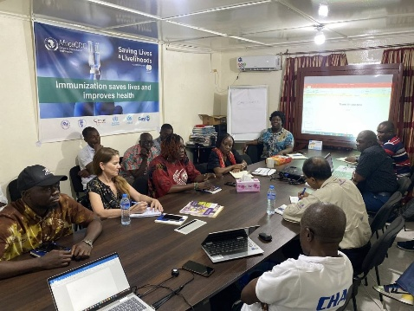
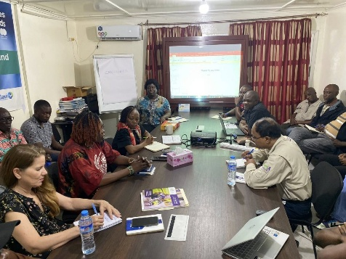
The day was filled with moments of inspiration, dialogue, and connection, leaving everyone with renewed enthusiasm for collaboration. CHAL remains deeply grateful for the partnership with Hope and Healing Canada, whose support and engagement continue to strengthen our programs and amplify our impact. As we look to the future, CHAL is excited about the opportunities for stronger collaboration, knowledge exchange, and shared initiatives with Hope and Healing Canada. Together, we continue to bring hope, healing, and quality healthcare to communities across Liberia.
