Project/Event

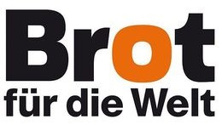
Bread for the World (BROT)

Building resilient health care and safe communities in Liberia through faith-based organizations.

Background:
In May 2021, CHAL signed an agreement with Bread for the world to implement a project titled “Building resilient health care and safe communities in Liberia through faith-based organizations”. The project has been implemented in Bong, Nimba, Montserrado, Bassa and Rivercess counties. It is an initiative led by CHAL that prioritizes strengthening 20 faith-based health facilities in Liberia. Its primary aim is to empower healthcare workers and foster community engagement.

Achievements:
Health Worker Training: Thus far, the project has made commendable progress by equipping 90 health workers with essential skills, enabling them to handle obstetric emergencies, offer family planning counseling, and administer precise treatment for pregnant women with malaria. This achievement significantly enhances maternal and neonatal healthcare services.
Outreach Visits: The project conducted 2000 outreach visits, significantly improving access to immunization services and promoting awareness about family planning. These efforts played a pivotal role in advancing healthcare access and directly delivering crucial services to communities, setting the stage for improved health outcomes.
Supervision Visits: The team executed at least 180 out of the planned 240 quarterly visits, providing a vital platform for assessing services and on-site mentoring and fostering continuous improvement in healthcare delivery within 20 health facilities.
Training in IPC and Customer Care: The oganization successfully trained 150 health workers in infection prevention and 220 in customer care, equipping them with vital communication and empathy skills and significantly enhancing the overall patient experience.
Medical Equipment and Facility Improvement: The project provided essential medical equipment to 20 health facilities and undertook significant infrastructure improvements, including 3 incinerator constructions, 1 placenta pit construction, 2 solar lighting installations, and 4 minor repairs across all facilities.
Training for TTMs and CHFs: Engaging communities through the SALT Approach, the project trained 75 traditional midwives (TTMs) and all 200 community health facilitators (CHFs), establishing robust connections between healthcare providers and community dwellers.
Meetings: Successfully organized and held meetings for nine out of the intended 12 quarters, establishing a robust relationship between community dwellers and healthcare workers.
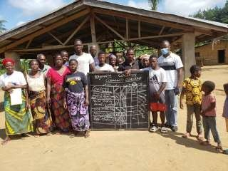
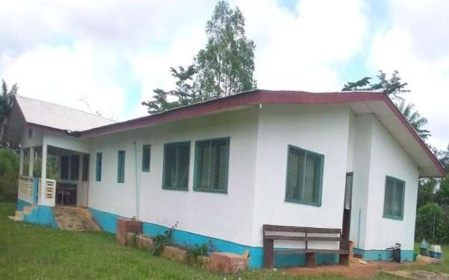
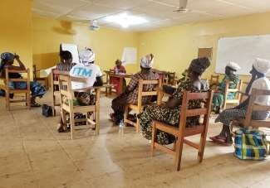
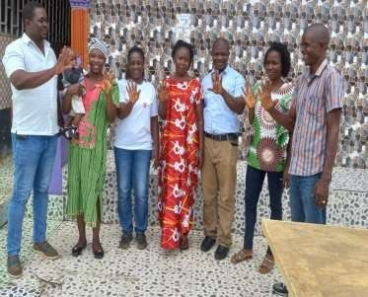
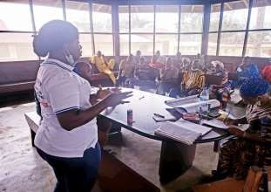
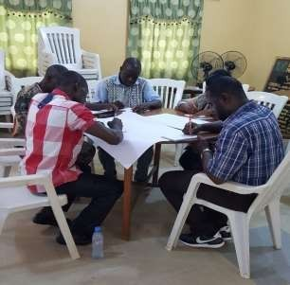
Outcomes and Impacts: Noteworthy outcomes include a 14.7% increase in institutional deliveries, a 17% rise in ANC visits, a 59% surge in family planning counseling for adolescent girls, and a 5% decrease in malaria cases during pregnancy. Over 477,000 individuals are actively engaged in healthcare services provided by faith-based facilities, showcasing their essential role in delivering accessible healthcare to the community (DHIS2-HMIS).
