Projects / Events

CHAL @ 50: Groundbreaking of the Multipurpose Building and Fundraising
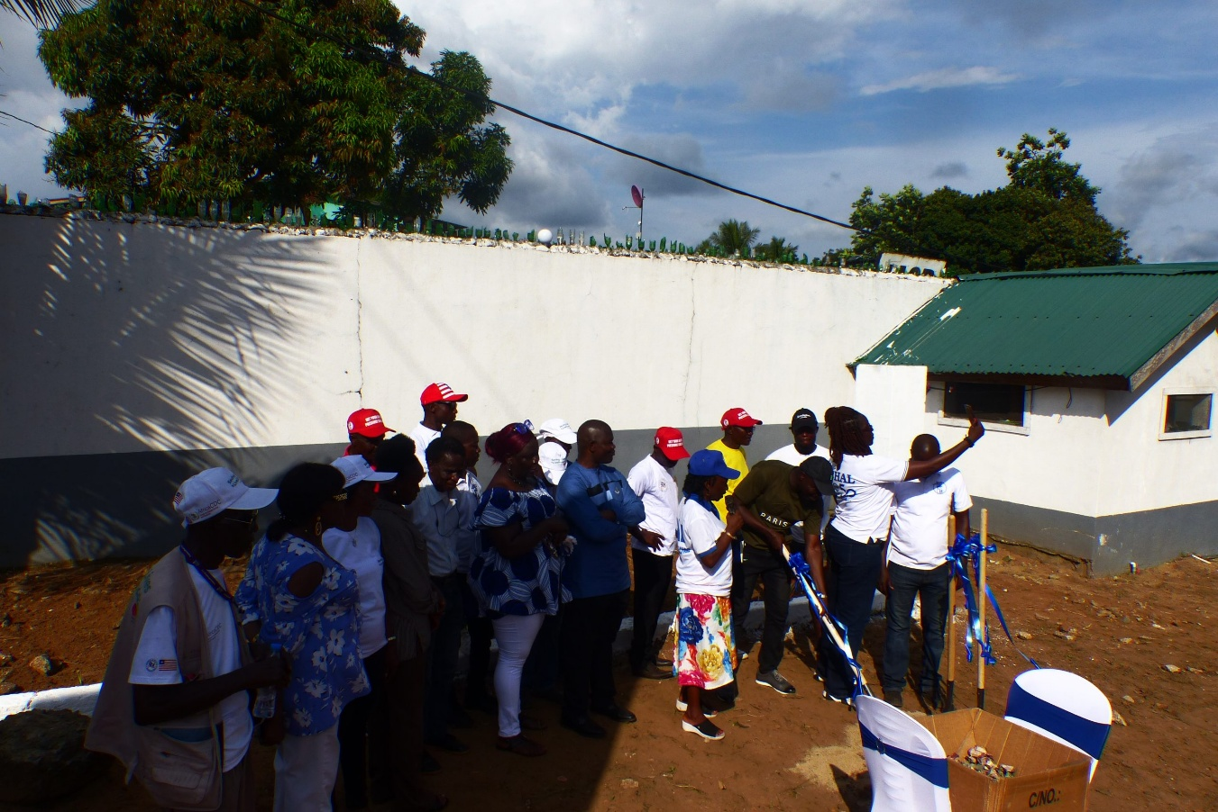

On 14th November, the Christian Health Association of Liberia (CHAL) reached a historic milestone in its 50-year journey with the groundbreaking of its multipurpose building and fundraising campaign. The ceremony, held at CHAL’s compound under the auspices of the Bishop of the Episcopal Church of Liberia, marked the beginning of a bold new chapter — one that blends faith, vision, and sustainability. For five decades, CHAL has united Christian health facilities and churches across Liberia in the mission of delivering compassionate, community-centered healthcare. This groundbreaking initiative represents more than a construction project; it is a strategic step toward financial independence, ensuring that CHAL can sustain its mission and cover core costs through income-generating activities.

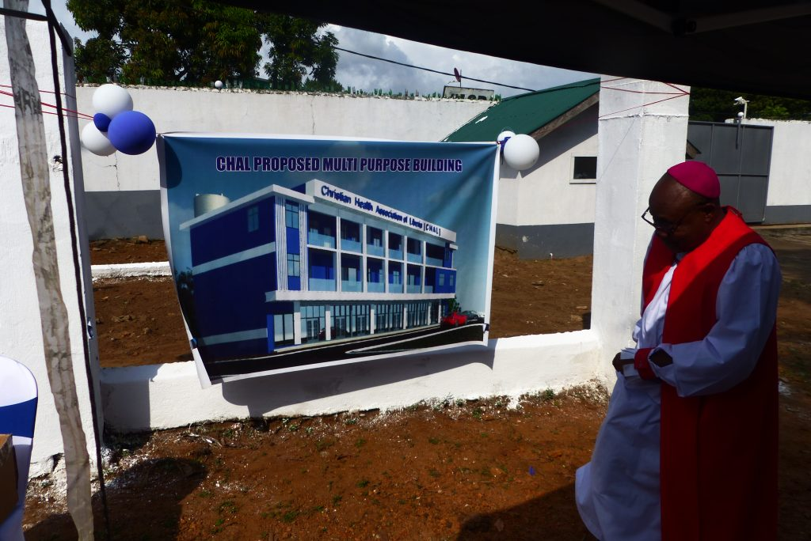

A Spirit of Generosity and Unity
The afternoon ceremony was filled with gratitude, anticipation, and a strong sense of unity. Leaders, members, and partners gathered to witness the symbolic turning of soil — a gesture that signified not only the start of construction but also the collective commitment to CHAL’s future.
A fundraising campaign was officially launched, with member facilities contributing between USD 100 – 500. Private contributions from members of the secretariat and churches added to the effort, demonstrating the shared responsibility and faith-driven generosity that has always defined CHAL’s work. Looking ahead, CHAL intends to engage traders, partners, and well-wishers in a broader fundraising effort. By leveraging
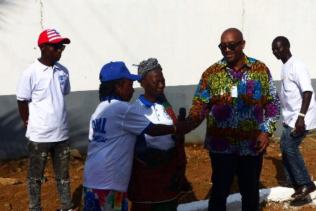
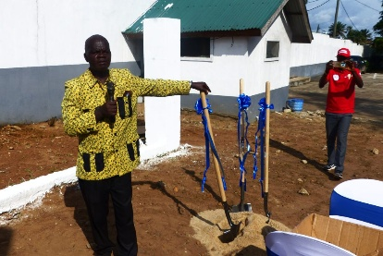
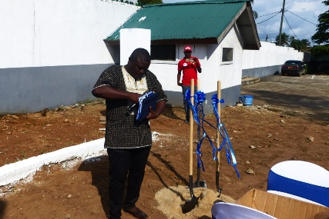
networks and goodwill, the organization aims to build a strong financial foundation that will allow it to thrive for generations to come.

The Multipurpose Building: A Vision in Three Phases
The multipurpose building is designed to be constructed in three phases, each carefully planned to generate income while serving the community:
- Shops for rent – Estimated at USD 150,000, these commercial spaces will provide steady rental income, ensuring CHAL has a reliable stream of funds to support its mission.
- Meeting and training facilities – With a projected cost of USD 90,000, these facilities will empower CHAL to host workshops, seminars, and training sessions, strengthening capacity across member institutions and beyond.
- Small guest apartments – Budgeted at USD 150,000, these apartments will accommodate visitors, partners, and program participants, while also generating revenue through hospitality services.
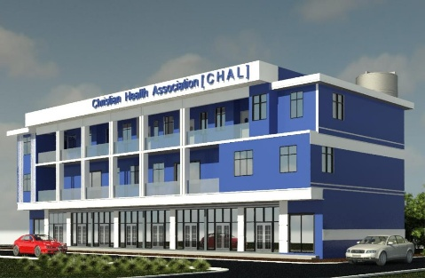
Together, these phases embody CHAL’s vision of sustainability, blending practicality with service, and ensuring resilience in the face of future challenges.
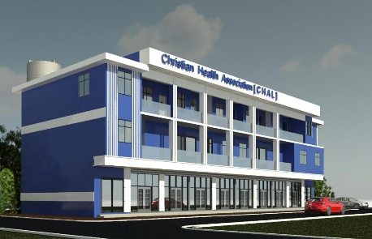
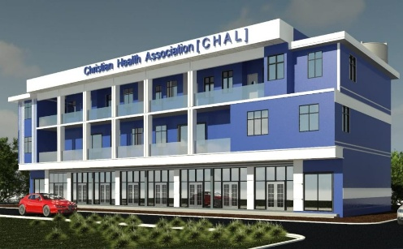

A Courageous Step of Faith
The groundbreaking of the multipurpose building is not merely about infrastructure. It is a courageous step taken in good faith, rooted in the belief that CHAL’s mission must endure and expand. By investing in property development, CHAL is embracing innovation while staying true to its spiritual foundation.
The Bishop’s presence underscored the sacred nature of this endeavor, reminding all in attendance that faith and action must walk hand in hand. As CHAL celebrates its 50th anniversary, this initiative stands as a testament to resilience, vision, and the unwavering commitment to serve communities across Liberia.

Looking Toward the Future
The journey ahead will require perseverance, collaboration, and continued generosity. Yet the groundbreaking ceremony has already set the tone: CHAL is ready to build, ready to grow, and ready to sustain its mission for generations to come.
As the soil was turned on that November afternoon, it symbolized more than the start of construction. It symbolized hope, courage, and the promise of a future where CHAL’s impact is not limited by financial constraints, but empowered by sustainable resources.
With faith as its foundation and community as its strength, CHAL steps boldly into the next 50 years — building not just a multipurpose facility, but a legacy of health, service, and transformation.

Projects / Events

CHAL @ 50: March for Health
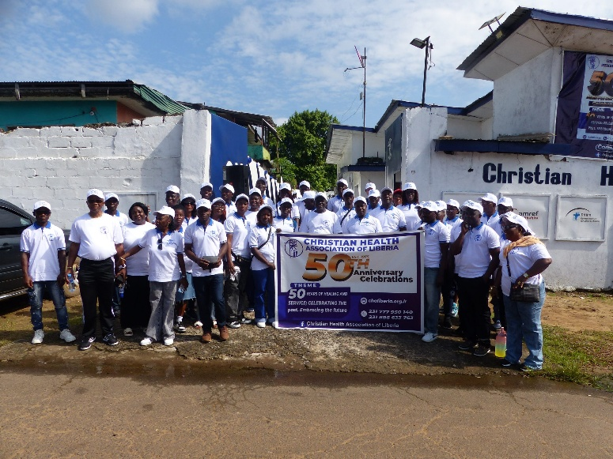

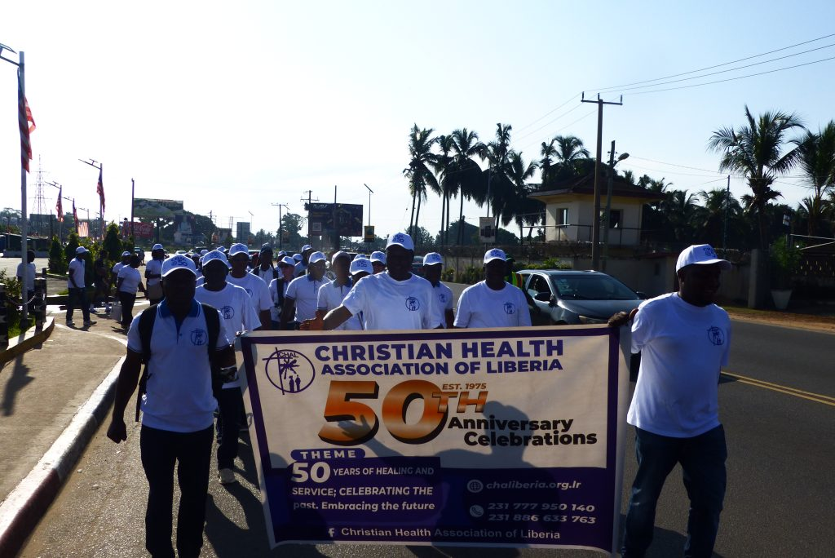
On 15th November, the Christian Health Association of Liberia (CHAL) continued its 50th anniversary celebrations with a vibrant March for Health through the city. Organized to give greater visibility to CHAL’s mission and impact, the march was a colorful and spirited occasion that brought members together while sharing the vision of health and hope with the wider community.

A Parade of Purpose
The march drew between 50–70 participants, representing CHAL’s member facilities, churches, and partners. Accompanied by the lively sounds of a brass band, the procession filled the streets with energy and joy. The presence of the Liberian police ensured safety and order, allowing the event to unfold smoothly and peacefully.
For CHAL, the march was more than a public display. It was a symbol of unity and visibility, reminding the city of the vital role CHAL has played in health and community development for five decades.

Strengthening Bonds, Sharing Vision
Participants described the march as a good exercise in fellowship and solidarity. Walking side by side, members strengthened bonds across institutions and reaffirmed their shared commitment to CHAL’s mission.
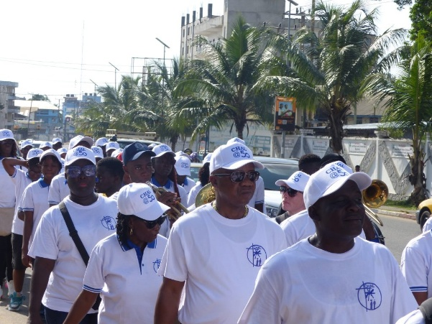

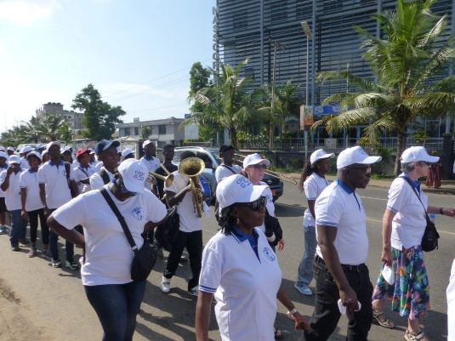
The march also served as a platform to share CHAL’s vision with others, reaching beyond the association’s immediate circle to engage the public. By bringing health to the streets, CHAL demonstrated that its work is not confined to clinics and offices — it is a movement rooted in community, faith, and service.

A Celebration of CHAL @ 50
The March for Health was part of a series of activities marking CHAL’s golden jubilee. Together with the groundbreaking of the multipurpose building and fundraising campaign, the march highlighted both CHAL’s legacy and its forward-looking vision.
While the groundbreaking ceremony symbolized sustainability and growth, the march embodied visibility, unity, and outreach — reminding all that CHAL’s strength lies in its people and their collective spirit.

Looking Ahead
As CHAL steps boldly into its next 50 years, the March for Health stands as a reminder that visibility and unity are essential to sustaining impact. By marching together, members not only celebrated the past but also declared their readiness to embrace the future.
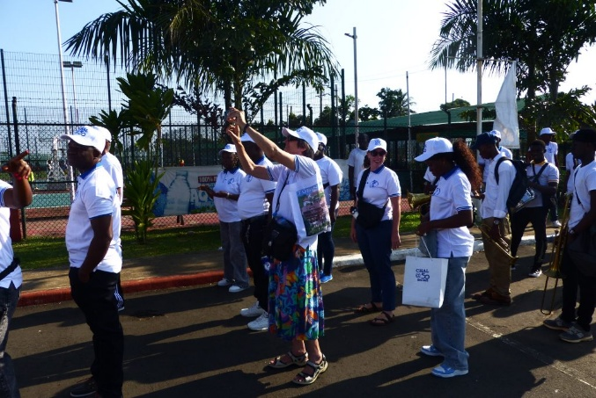


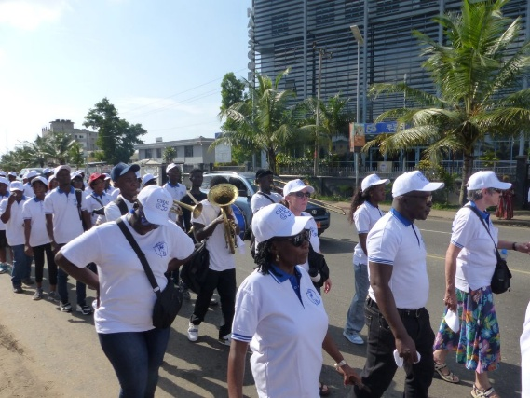

With music in the air, faith in their hearts, and vision in their steps, CHAL’s March for Health was more than a parade — it was a living testimony of resilience, service, and hope for Liberia.




