Project/Event

CHAL Drugs Supply Unit (DSU)
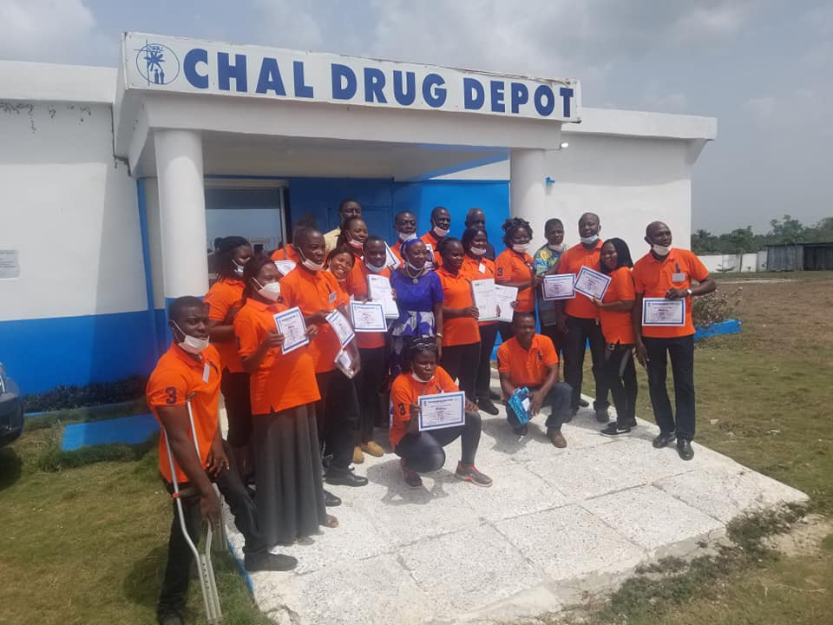

INTRODUCTION:
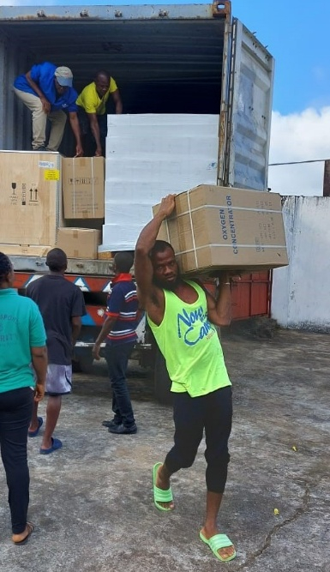
CHAL Drugs Supply Unit (DSU) was established to provide quality, effective and efficient supply of essential medicines and medical supplies to faith-based health facilities, NGOs and non-members of the Counties in Liberia to generate cost recovery for the sustainability of the DSU program.

HISTORY OF THE DRUGS SUPPLY UNIT (DSU):
CHAL’s first drug supply unit (DSU) operated up until the 1990s and became dormant due to the civil war. There was an attempt to reactivate the DSU in 2006 with funding from IMA World Health. It was intended to be a sustainable revolving drug fund principally responsible for procuring and selling medicines and medical supplies to its constituents. In the face of a huge humanitarian operation during the war years, CHAL could not sustain its DSU program because its member health facilities were given free supplies and donations by other partners. In 2018, the German Institute for Medical Mission (Difaem) provided seed funds and technical assistance for the reactivation and development of the Drugs supply system to CHAL. Besides the small supply of medicines CHAL had in stock at the time, Difaem contributed medicines and medical supplies worth €100,000 Euros (approximately $110,000.00 United Stated dollars). The Drugs Supply Unit (DSU) was re-activated with two staff and a storage facility only in Monrovia. The project directly benefited CHAL in terms of its management of the DSU and served health facilities, particularly the faith-based institutions. Approximately 100,000 patients received care through faith-based health facilities in rural Liberia as indirect beneficiaries of the improved and decentralized DSU of CHAL. The project encompassed constructing and equipping a drug depot in Gbarnga, Central Liberia. There is a training component for dispensers and untrained dispensing staff of some of the CHAL’s member health facilities among other things.

PURPOSE OF THE CHAL’S DSU PROGRAM:
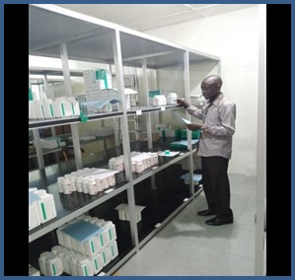
The Christian Health Association of Liberia (CHAL) operates and constantly works to improve the Drugs Supply Unit (DSU) in order to offer efficient and effective supply of essential medicines and medical products to faith-based health facilities and NGOs around the Counties in Liberia. It is meant to cover its own running costs and generate a surplus that can be re-invested into expanding the stock of available medicines and medical supplies, thereby sustaining a system of reliable and continuous provision of high quality and affordable essential medicines and medical supplies. These efforts complement the supply services of the Government of Liberia and thus aid in facilitating access to health care services and healing for the people in Liberia. Currently, CHAL has a Pharmacist Superintendent and Drugs Supply Unit Manager with a team of staff that are charged with the responsibility of CHAL’s Drugs management.

Activities
- Received and processed daily requisitions from customers, non-member health facilities and member health facilities of pharmaceutical supplies including preparation of invoices, picking of health products, and packaging of health commodities.
- Continually practiced hygiene in both warehouses by cleaning the drugs warehouses including cleaning floors and shelves. Similarly, hoeing and cutting grass around the Drugs Depot/warehouse, planting of trees and flowers in the compound in Melekie.
- Continue to create public awareness of the existence of the Drugs Depot in Melekie, Bong County, Liberia and Monrovia. This includes distribution of flyers, price lists to member and non-member health facilities, visitation of non-member health facilities in Gbarnga, Bong County and Monrovia to market CHAL’s health pharmaceutical commodities that are highly potent.
