Project/Event

COVID-19 SOLAR PROJECT
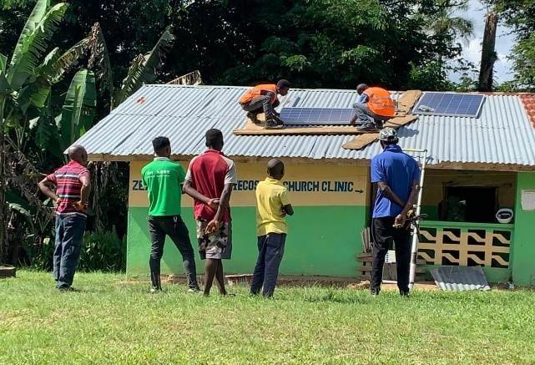

Implementation Period: December 2020 – August 31st, 2021

Project Title: Energy Generation Kit-Solar Rise (Project 532).

Source of funds: German Institute for Medical Mission (Difaem)

Background
The cooperative agreement between Christian Health Association of Liberia and German Institute for Medical Mission (Difaem) provides that the partner organization shall receive equipment /materials/medicines and shall be responsible for reception, importation, clearance and distribution of goods received. The project shall cover these local costs to the sum stated in the contract.
CHAL received two forty-foot (40’) containers of Energy Generation Kit Solar Rise (Solar Plates & Accessories) as gift for Nine (9) Member Health facilities of Christian Health Association of Liberia (CHAL), the consignment of solar equipment was generous donation from the people of Germany through its German Institute for Medical Mission (Difaem).
The donation covered facilities situated in four different counties of Liberia. The consignments of solar equipment were generous donation from the people of Germany through its German Institute for Medical Mission (Difaem).

PROJECT STRATEGIC APPROACH
CHAL represents 35% health service provider in Liberia and serves vulnerable population in rural and hard to reach areas. CHAL intends to create safe health care environment to its member health facilities through the supply of solar energy lightening to all of its eighty-one (81) registered members through advocacy and lobbying with its friendly partners around the world.
This endeavor aligns with our institution vision and mission, which states the following.

VISION
To provide access to health care service and healing for all people in Liberia.

MISSION
Dedicated to the healing ministry of our Lord & Savior Jesus Christ through advocacy and provided holistic health care to in Liberia.
We are of the ardent conviction that the supply of solar energy lightening to all of our member health facilities is a cogent part of providing holistic health care services and it is an appropriate mechanism to minimize the death rate of mother and child during delivery under the cover of darkness or with minimum phone lights.

GOAL:
- To strengthen Maternal & Child Health (MCH) of Member Health facilities of CHAL
- Support Neonatal Care
- Promote ANC, labor and delivery at night.
- Provide lightening for night services.
- Provide basic training on maintenance of equipment.

OUT COME:
To contribute to the reduction of child and maternal morbidity and mortality, ensuring that both mother and child are safe during delivery, that no one must lose their life due to the lack of electricity at the given facility.

COST OF SHIPMENT
NO. | ITEM DESCRIPTION | 1st Shipment Cost | 2nd Shipment Cost | Total Cost in US Dollars
1 | Material, insurance, sea freight | 21.479.59 EU $25,990.30 US | 14,581.58 EU $17,643.71 US | $43,634.01
2 | Local Installation Cost |  |  | $7,942.00
3 | Local Clearing Cost | 4,733.00 | 4,583.00 | $ 9,316.00
4 | Distribution & Transportation Cost |  |  | $ 894.84
5 | Admin Cost |  |  | $1,094.75
6 | Solar Maintenance Training |  |  | $1,250.00
7 | TOTAL COST |  |  | $64,131.60

LIST OF HEALTH FACILITIES BENEFITTED FROM THE SOLAR PROJECT
N0 | Health Facility | Location
1 | Excellent Medical Clinic | Montserrado County
2 | Saclepea United Liberia Inland Clinic | Saclepea-Nimba
3 | Mid-Baptist Clinic | Tappita-Nimba
4 | Yekepa Free Pentecostal | Yekepa-Nimba
5 | United Pentecostal Church Health | Montserrado
6 | Fredai Medical health Center | Montserrado
7 | Ma. Tuwor community Clinic | Montserrado
8 | German Clinic (GERLIB) | Montserrado
9 | Forya Borma Hospital | Forya, Lofa County
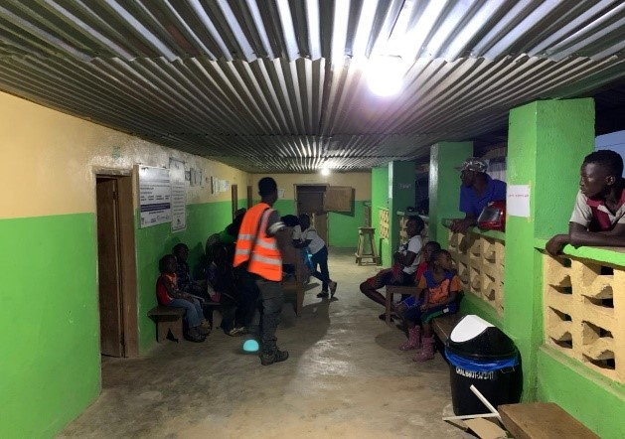
One of 5 facilities solar Installed in Zeayorzu Free Pentecostal Mission Clinic in Lofa
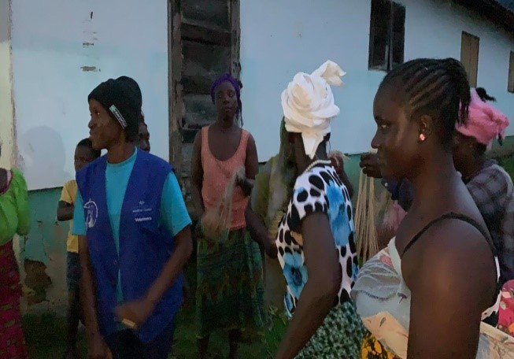

Community Members celebrates the Solar Lightening up of their Health facility.

