Project / Events

Closing Ceremony: IPTp-SP Pilot Project in Buu-Yao District, Nimba March 2024 – February 2025
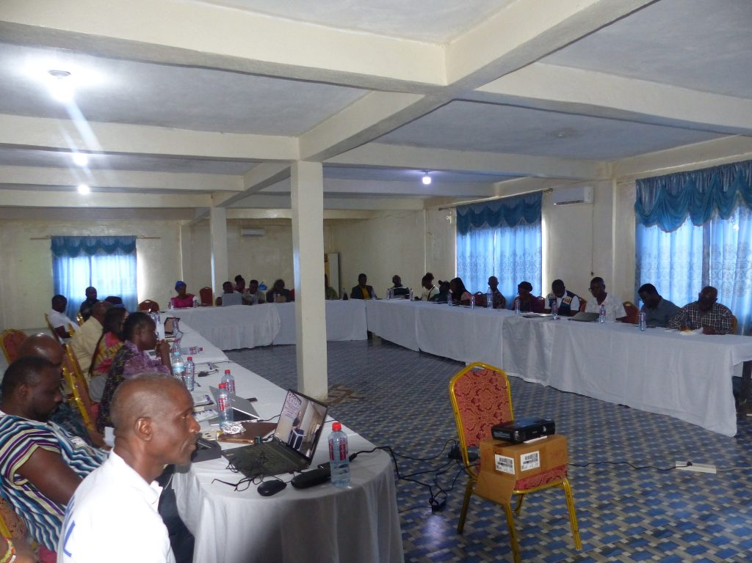

We proudly marked the successful completion of the Intermittent Preventive Treatment in Pregnancy with Sulfadoxine-Pyrimethamine (IPTp-SP) Pilot Project in Buu-Yao District, Nimba County. This one-year initiative was a landmark step toward reducing the burden of malaria among pregnant women, ensuring healthier pregnancies and safer deliveries in Liberia.

About the Project
The pilot project ran from March 2024 to February 2025 and was made possible through a strategic partnership between the Medicines for Malaria Venture (MMV), a Swiss foundation based in Geneva, and the Ministry of Health of Liberia, with funding from MMV and oversight from the RBM Partnership to End Malaria.
The project aimed to strengthen uptake and delivery of IPTp-SP services through:
- Health facility-based interventions
- Community engagement led by CHWs (Community Health Workers)
- Enhanced training for health personnel
The ultimate goal: reducing malaria-related complications in pregnancy and improving maternal and neonatal health outcomes in the target communities.
Achievements at a Glance
Over the course of the year, the IPTp-SP Pilot Project recorded notable successes, including:
Increased IPTp-SP coverage among pregnant women in Buu-Yao District
Improved training for health workers, resulting in higher service quality
Strengthened community-based outreach through CHWs
Significant reduction in malaria cases among expectant mothers in the targeted areas
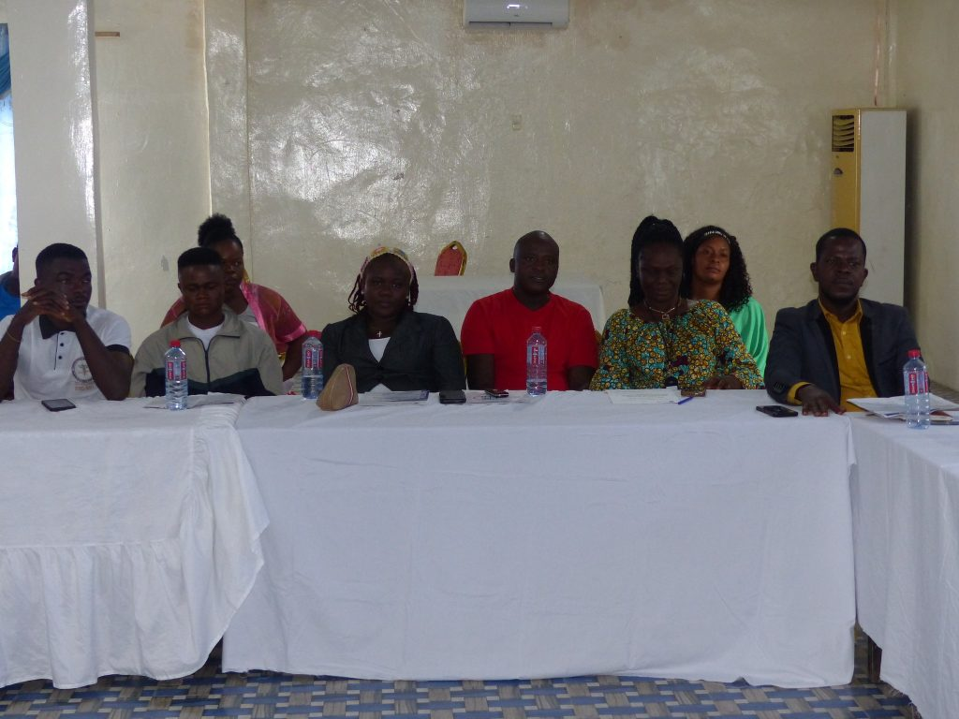
These outcomes demonstrate the power of well-coordinated, evidence-based malaria prevention strategies in strengthening maternal health systems.

Key Lessons Learned
The project highlighted several critical insights for malaria prevention:
- Community engagement is essential: CHWs played a central role in sensitization, outreach, and building trust among pregnant women.
- Training improves outcomes: Well-trained health workers delivered services more effectively, enhancing confidence in IPTp-SP.
- Resilient systems are needed: Challenges such as supply chain delays and initial data collection hurdles emphasized the importance of real-time monitoring and adaptive planning.
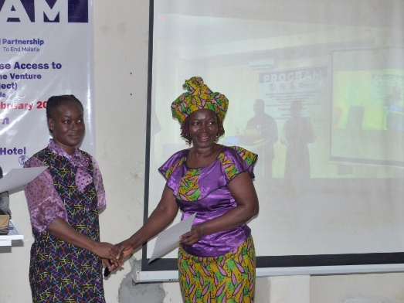
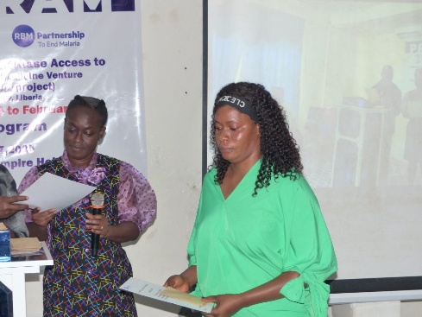
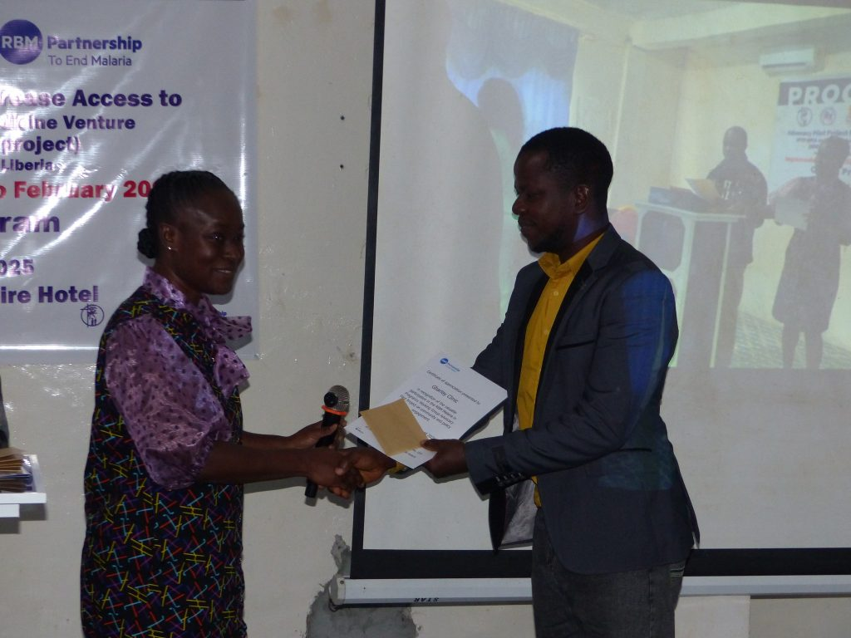
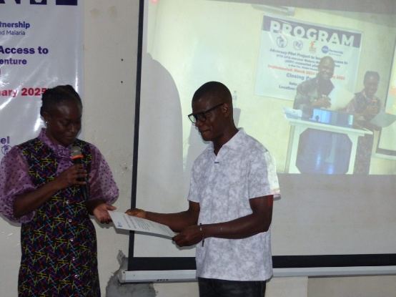
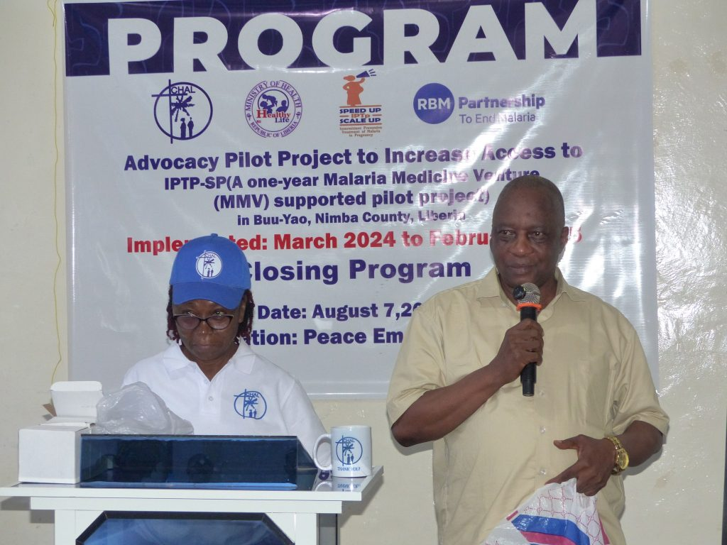
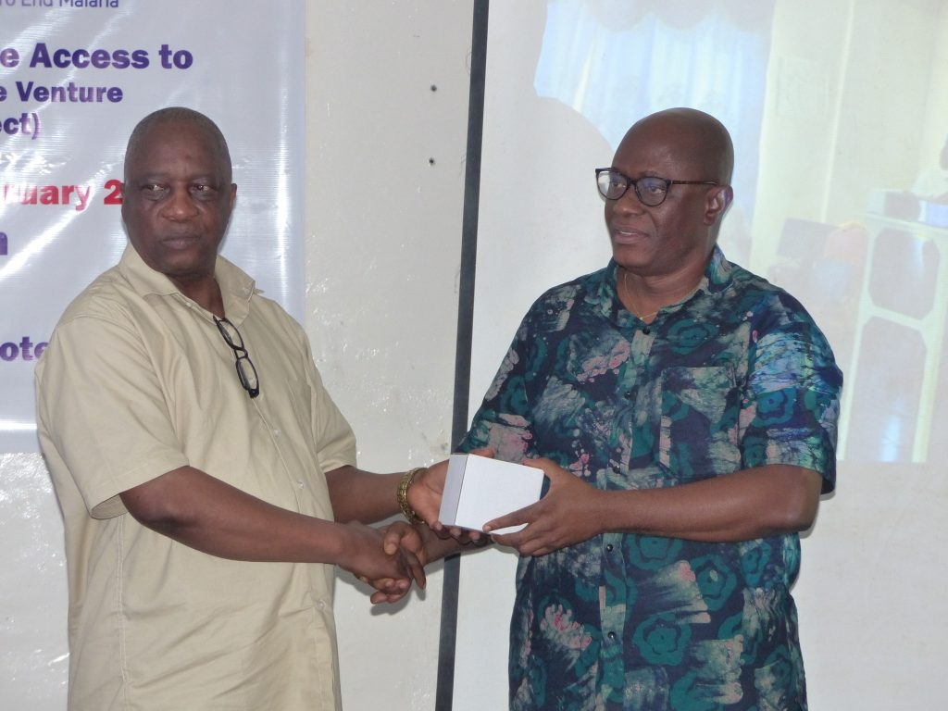
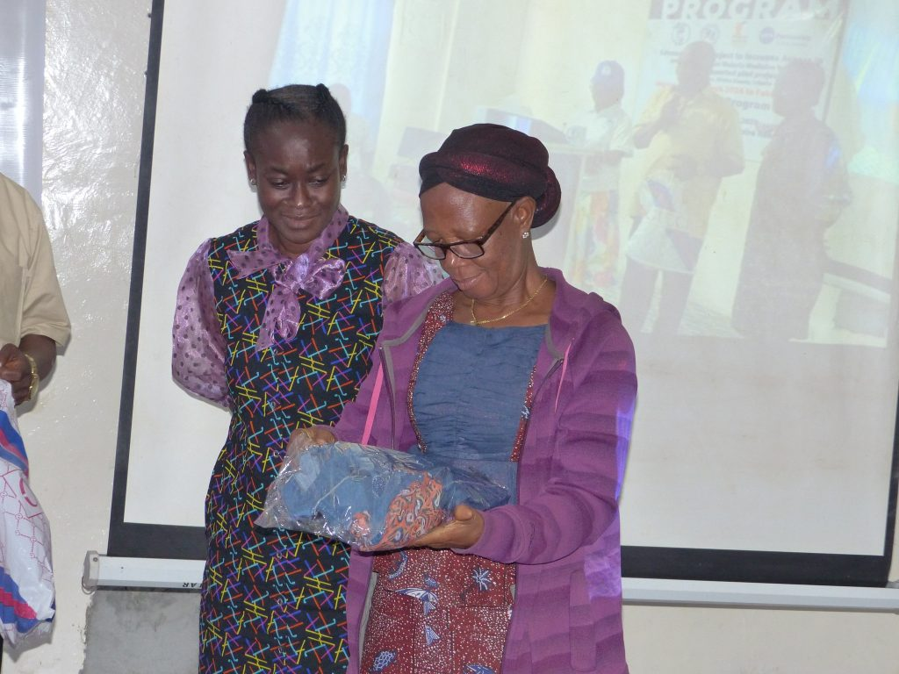
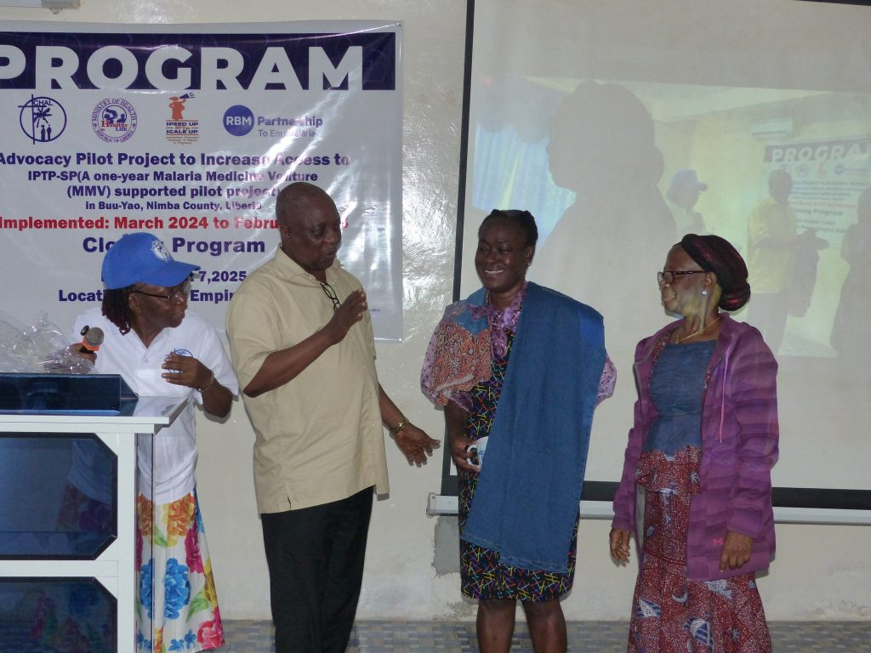
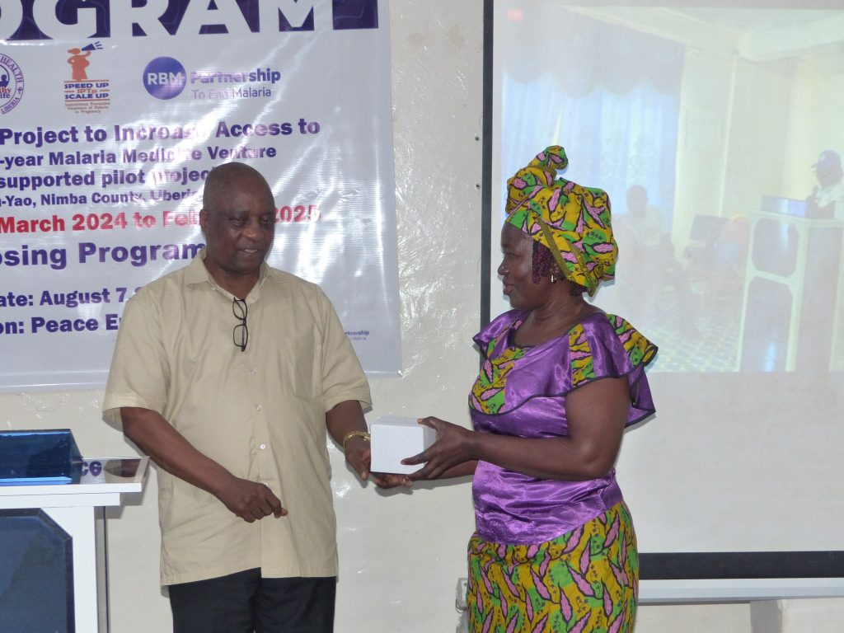

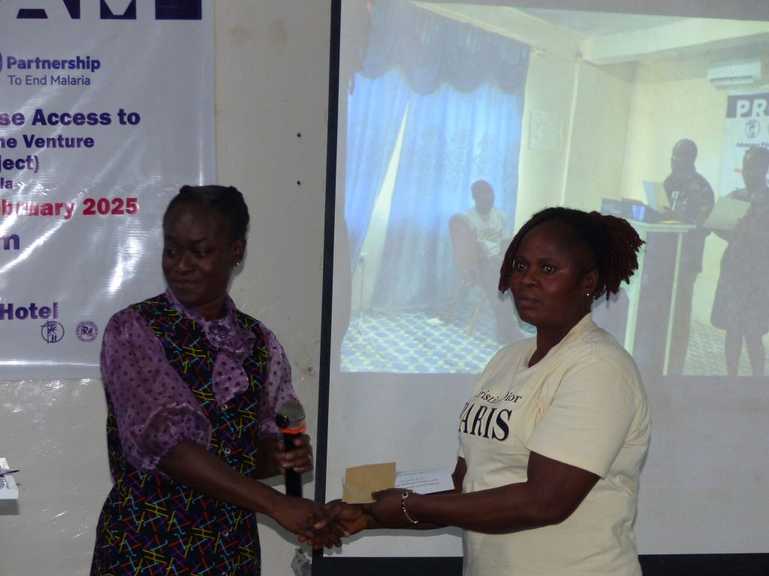
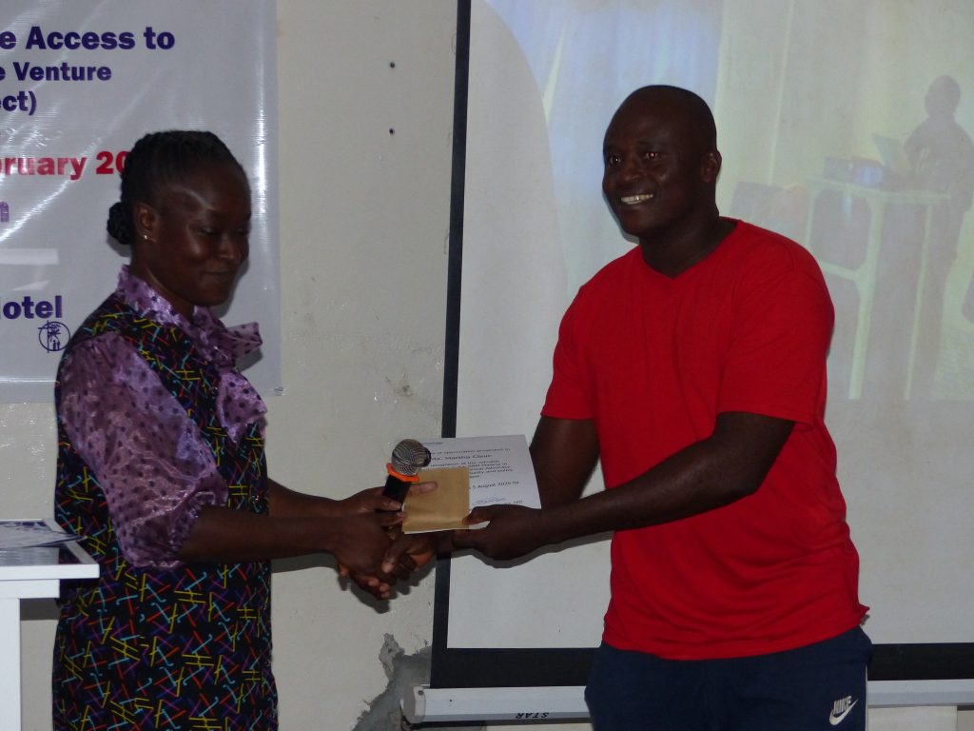
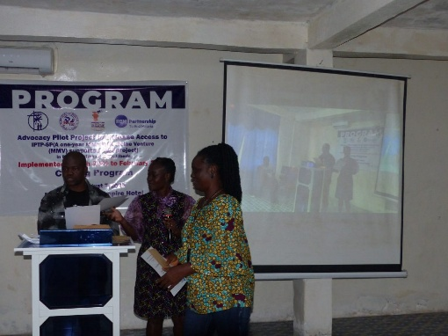
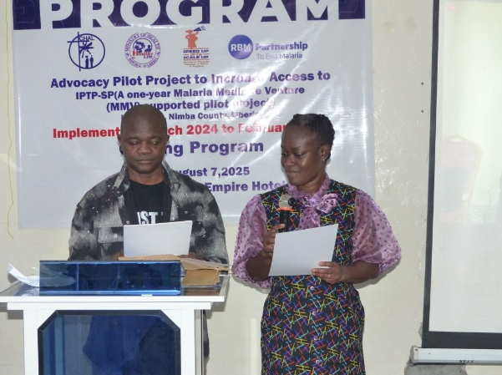
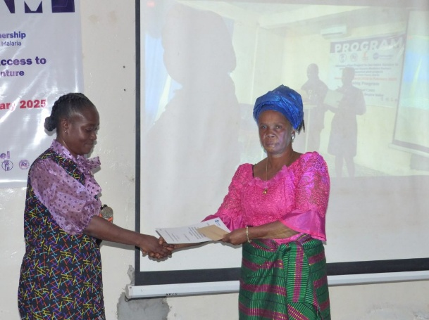
Special Thanks and Recognition
We extend our heartfelt appreciation to:
- All participating health facilities in Buu-Yao District
- Community Health Workers (CHWs) who tirelessly mobilized communities
- Local leaders who supported outreach and sensitization efforts
As a token of appreciation, certificates were awarded to outstanding CHWs and facility representatives, recognizing their incredible dedication and contribution to the success of this pilot.

Looking Ahead: Towards a Malaria-Free Liberia
The IPTp-SP Pilot Project in Buu-Yao District demonstrates how collaboration, community engagement, and targeted interventions can make a tangible difference in public health outcomes. Together, with partners, health workers, and local leaders, we are one step closer to a malaria-free Liberia, ensuring healthier mothers, safer pregnancies, and stronger communities.
