Project/Event

EPN (Ecumenical Pharmaceutical Network)
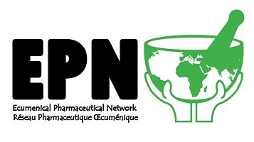

Ecumenical Scholarship for the Beneficiary for a 3-year Diploma Program

Background:
In January 2023, the Ecumenical Pharmaceutical Network (EPN) announced the availability of a Scholarship to support healthcare staff working in the pharmacies of church hospitals/health facilities to undertake Diploma courses (3year period) leading to the award of a pharmacy accepted in the applicant’s country.

Criteria for health facilities to submit applicant name/s were:
a. Have 50 beds or more as confirmed by the Church Health Association (CHA) or recognized authority.
b. Be preferably located in a rural or hard-to-reach area.
c. Be part of a Christian Health Association or an umbrella organization or network that is a paid-up member of EPN.
e. Be prepared to provide a letter of support for the candidate to attend the Diploma training and commit to employing the candidate during and after their studies.
Eligible candidates were to be in the employed of the health facility and have been nominated for the course by the hospital/health facility management and get a recommendation from them. A list of eight (8) applicants (with supporting documentations from their respective health facilities and Schools) from 5) health facilities were submitted to EPN for review and selection. Four (4) of the applicants were selected to benefit from the scholarship.


Patricia L. Murphy/Phebe Davidson T. Bullet/Foyah Borma Hospital



Ellenor K. Kamara/Bolahun Health Center Oretha W. Kollie/Curran Hospital

