Experience Improved Healthcare with Reliable, Affordable Oxygen Refilling Plant

CHAL Has Officially Launched a Modern Medical Oxygen Refilling Plant in Bong County, Meleke Town
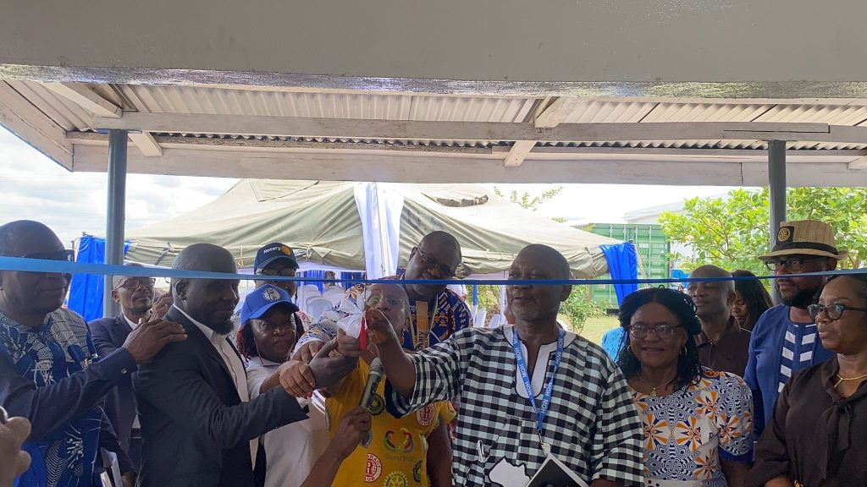
The Christian Health Association of Liberia (CHAL), in partnership with the Rotary Club of Sinkor (RCS), proudly announces the official opening of a state-of-the-art medical-grade Oxygen Refilling Plant in Bong County, Liberia.
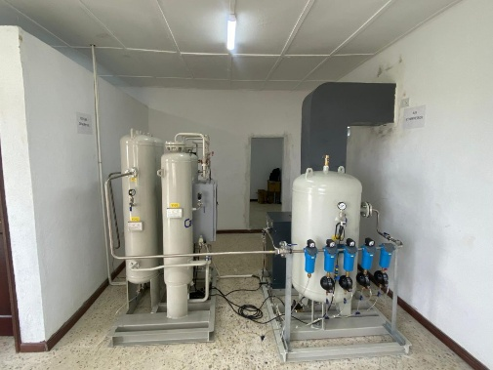
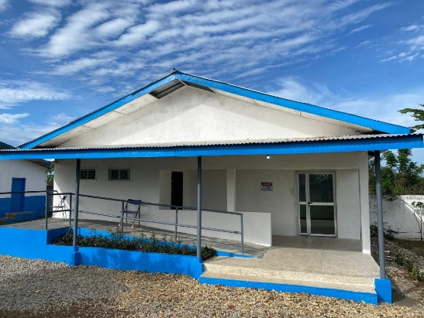
This landmark initiative marks a major milestone in strengthening the nation’s healthcare system — ensuring that life-saving oxygen is now readily available, affordable, and accessible to hospitals and health centers across the region.
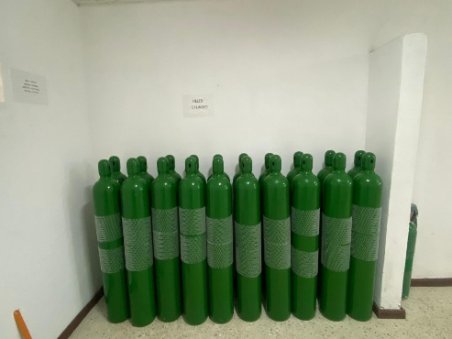
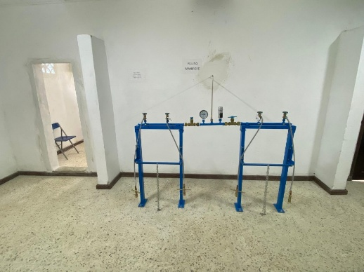
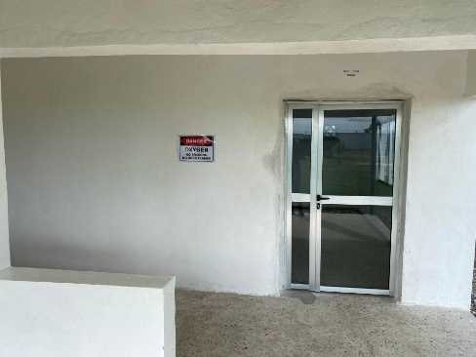
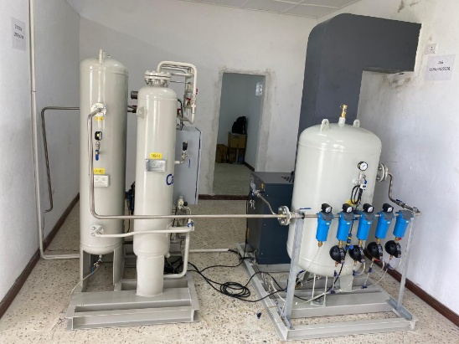

A Lifeline for Healthcare Facilities
The new oxygen refilling facility, located in Meleke Town along the Phebe–Gbarnga Highway, between Cuttington University (Suacoco) and Gbarnga City, is strategically positioned to serve both urban and rural healthcare institutions.
With this development, health facilities no longer have to travel long distances or face shortages during emergencies. The plant ensures that oxygen — a critical component for managing respiratory illnesses, childbirth complications, trauma cases, and COVID-19 — is now accessible when and where it’s needed most.

Reliable, Affordable, and Locally Managed
CHAL and RCS have established a robust management framework that prioritizes quality assurance, affordability, and sustainability.
Oxygen cylinder refills are available at cost-effective rates, making it easier for both public and private health facilities to maintain consistent oxygen supply. The plant operates daily from 9:00 AM to 4:00 PM, with dedicated staff ready to respond to urgent requests and ensure that healthcare facilities can deliver uninterrupted critical care services.

A Step Toward a Healthier Liberia
The establishment of the Oxygen Refilling Plant represents more than just infrastructure — it’s a commitment to strengthening Liberia’s healthcare resilience. It supports emergency response systems, reduces delays in treatment, and reinforces CHAL’s broader mission to ensure quality healthcare for all Liberians, especially those in hard-to-reach areas.
With oxygen now within reach, health workers are better equipped to provide timely care to patients facing respiratory distress and other critical conditions.

Visit or Contact Us
Plant Location: Meleke Town, Phebe–Gbarnga Highway (Old Football Field)
Head Office: CHAL Headquarters, 21st Street, Fiamah, Sinkor, Monrovia
Gbarnga: 0776-805-561 / 0881-615-529 / 0770-413-206
Monrovia: 0777-950-140 / 0777-025-717 / 0776-904-992

Together, We’re Saving Lives — One Breath at a Time
CHAL, the Rotary Club of Sinkor, and all partners extend heartfelt appreciation to everyone who contributed to this milestone. The Oxygen Refilling Plant stands as a symbol of hope, innovation, and partnership, advancing Liberia’s journey toward sustainable healthcare for all.
