Project/Event

Hospital Partnership « Neonatal Resuscitation
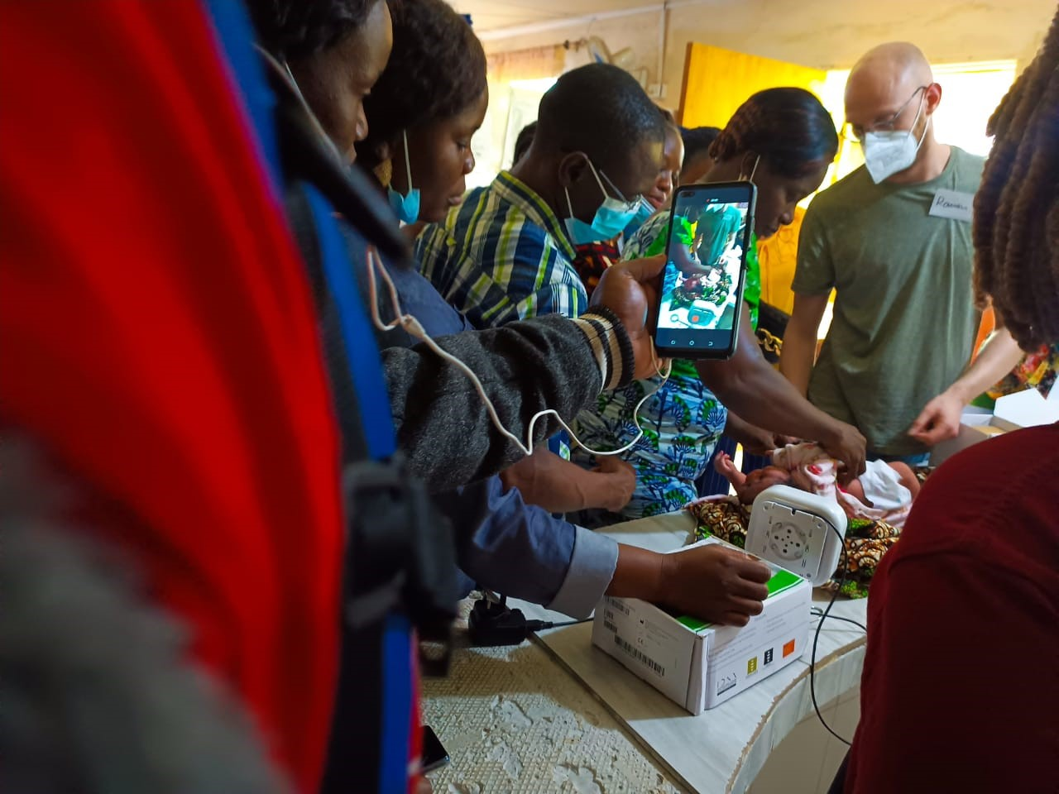

Project Duration: 01.09.2022-30.11.2023

Project objective and indicators:
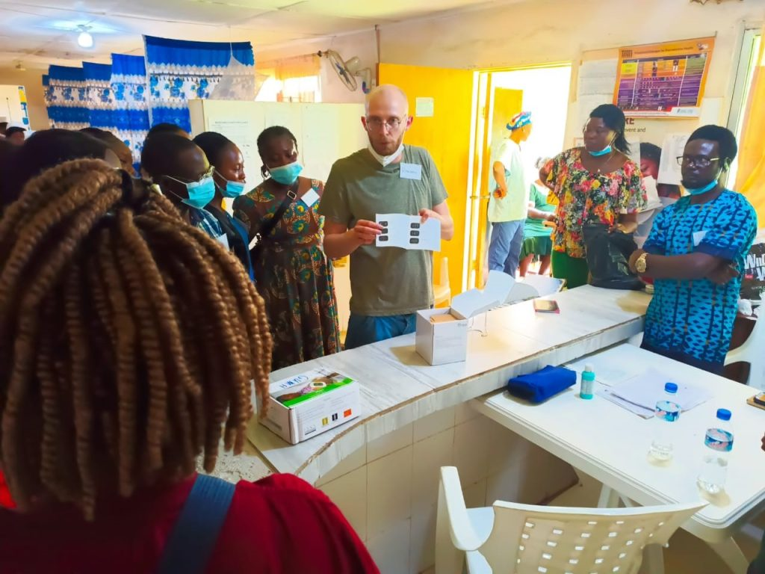
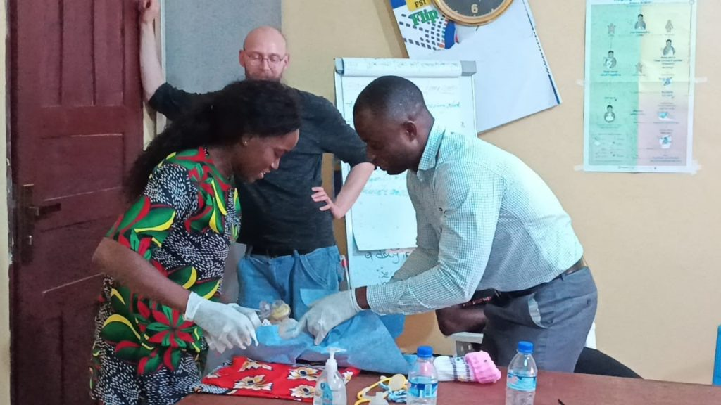
The objective of the project: The health of new-borns in three partner hospitals Ganta United Methodist Hospital, Curran Lutheran Hospital and Foya Boma Hospital is improved.

Background
DIFAEM and PAEDSIM in Collaboration with CHAL conducted a refresher Neonatal resuscitation training on October 23-24, 2023 for health facility staffs. Each of the 3 hospitals rendering neonatal services was represented. For Ganta united Methodist Hospital, 5 staffs including a doctor who participated for the first time were represented. Curran Lutheran Hospital was represented by 5 staffs including two new participants (one Doctor and one Nurse) and Foya Borma Hospital was represented by one staff due to shortage of staff in the hospital. 3 CHAL staffs and 1 staff from Winifred J Harley College of health Sciences also represented. Total category of participants were 2 medical doctors, 2 Physician assistants, 5 midwives, 5 Registered Nurses and CHAL Executive director making it a total of 15 participants.
The training was facilitated online by Carina Dinkel from DIFAEM and Roman Kremling from PAEDSIM and Co-facilitated in person by 3 selected participants (Zlangbah Dahn, Felecia Gborweah, and Patricia Y. Larblah) who benefited from the previous Neonatal resuscitation training conducted in November 2022 in Ganta City. Carina Dinkel is a consultant for international health work at the German Institute for Medical Mission (Difam). Roman Kremling is a specialist in paediatric intensive care at the University Hospital of Tubingen. He works as PAEDSIM instructors at the EK. Glangbah Dahn is a registered midwife, she supervises the labour, delivery and post-partum wards at Ganta United Methodist Hospital. Felecia Gborweah is a registered Nurse, she supervises the paediatrics ward at Ganta united Methodist Hospital, and Patricia Y. Larblah who also served as co-facilitator is a registered Nurse, and an educator at the Winifred J Harley College of Health sciences in Ganta City, Nimba county.

Achievements
- 15 participants benefited from the two days refresher training in Ganta, Nimba county. Eleven (11) of the participants were people who benefited from the previous training while 4 new participants benefited. For the new participants, 2 came from Curran Lutheran Hospital, 1 from Ganta United Methodist Hospital and 1 from CHAL. Three of the participants who benefited from the previous trainings served as co-facilitators during the two days training in Ganta.
All the staffs trained from the three hospitals (Foya Borma, Curran Lutheran and Ganta United Methodist Hospitals) are able to confidently resuscitate new-born babies according to standards as the result of the neonatal resuscitation training.

Data from participating hospitals
 | 4th quarter 2022 | 1st quarter 2023 | 2nd quarter 2023 | 3rd quarter 2023
total number of deliveries | 103 | 90 | 132 | 101
number of babies discharged after 24h | 63 | 58 | 92 | 56
number of neonatal deaths | 1 | 1 | 0 | 0
number of babies kept for intensified monitoring and therapy | 0 | 2 | 5 | 3
number of resuscitations conducted | 0 | 2 | 3 | 9
diagnoses for neonatal deaths (list all and number of newborns affected) | Neonatal Jaundice 1 | Preterm baby-1 | 0 | 0
number of death audits conducted | 1 | 1 | 0 | 0
diagnoses for intensified monitoring and therapy (list 5 most frequent and number of newborns affected) | 1 0 | 1.Birth asphyxia-2 | Birth asphyxia– 3 | Birth asphysia-2
 | 2 0 | 2 | neonatal sepsis -2 | neonatal sepsis-1
 | 3. 0 | 3.
 | 4. 0 | 4. | 4.
 | 5. 0 | 5. | 5.
Photo of two co-facilitators (Zlangbah Dahn and Felecia Gborweah) displaying to participants how to provide resuscitation to neonate during the Neonatal resuscitation training (online and in person) conducted at Winifred J. Harley college of Health sciences, Ganta City, By DiFaem and PAEDSIM in collaboration with CHAL.

