Project/Event

Pharma 700 (Difaem) Project
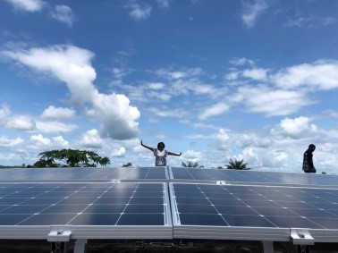

Project title:
Strengthening of CHAL with regard to procurement structures and improvement of pharmaceutical management in their health care facilities

Duration:
May 2019 – present

Background
The Christian Health Association of Liberia (CHAL) was founded in 1975 by four Christian health facilities for the purpose of jointly procuring and distributing medicines and supplies. CHAL’s first drug supply unit (DSU) operated up until the 1990s and became dormant civil war.
There were attempts to reactivate the DSU in 2006 with funding from IMA World Health. It was intended to be a sustainable revolving drug fund principally responsible for procuring and selling drugs and medical supplies to its constituents. In the face of a huge humanitarian operation during the war years, CHAL could not sustain its DSU because its member health facilities were given free supplies and donations by other partners.
Over the years, the context in Liberia has changed from emergency to recovery and development. Along with this changing context, donations and free services are dried up. CHAL and its member had to face up to the reality of the changing environment and organize their services in a rational, efficient and sustainable manner. One way of doing this was to revert to a well-functioning drug supply unit (DSU).
With support from Difaem through Bread for the world, CHAL reactivated its drug revolving program.

Achievement or solution showing impact:
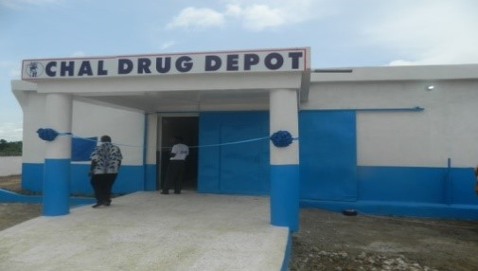
Constructed and equipped a drug depot in Melekie, Gbarnga, Bong County that worth…US$ 150,000.00

Refurbished the dispensing room and drug depot in Monrovia, Montserrado county,
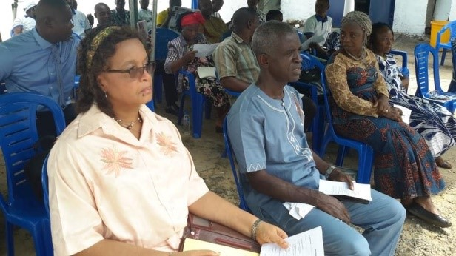
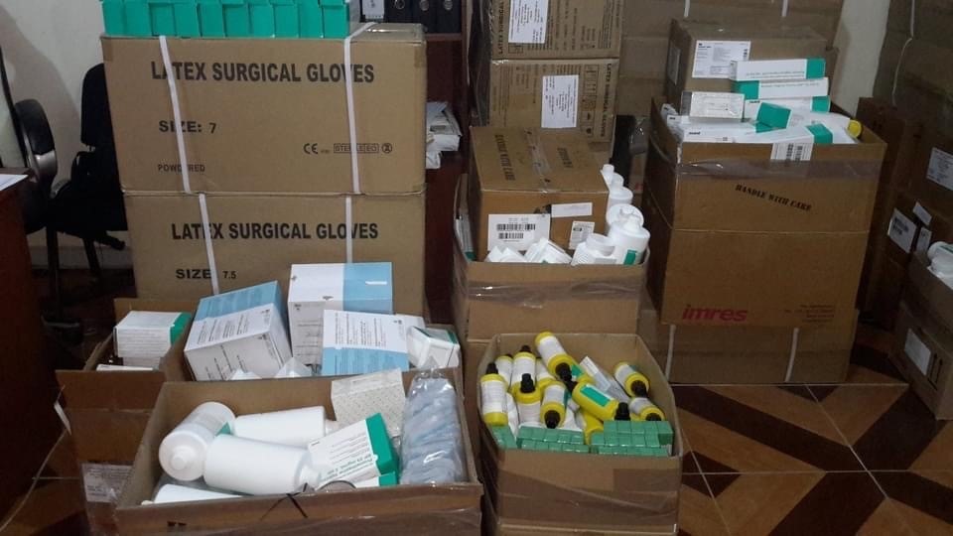
Initiated the Drug Revolving Fund program to 25 health facilities comprising of six (6) hospital, five (5) health Centers and fourteen (14) Clinics. Seed drugs worth US 43,000 was intended to enhance the quality of health services by ensuring the availability of essential good quality, affordable and medicines and medical supplies at all times and that medical supplies are replenished using money collected from the sales of supplies at the health facilities thereby increasing the efficiency of drug services as well as generating additional revenues.

LIST LIST OF HEALTH FACILITIES THAT BENEFITTED FROM THE DRF
NO. | NAME OF CHAL FACILITY) | TYPE | LOCATION | County | Amount
1 | Curran Lutheran Hospital | Hospital | Zorzor, | Lofa | 3,314.84
2 | Foya-Borma Hospital | Hospital | Foya | Lofa | 3,314.84
3 | Ganta United Methodist Hospital | Hospital | Ganta | Nimba | 3,314.84
4 | Phebe Hospital & School of Nursing | Hospital | Gbarnga | Bong | 3,314.84
5 | SDA Hospital | Hospital | Monrovia | Montserrado | 3,314.84
6 | St. Timothy Hospital | Hospital | Robertspsort | Montserrado | 3,314.84
7 | AFB Health Center | Health Center | Kokoyah Rd, Gbarnga | Bong | 1,838.54
8 | GERLIB Clinic & Health Center | Health Center | Somalia Drive | Montserrado | 1,838.54
9 | St Peter’s Claver Catholic Health Center | Health Center | Buchanan | G. Bassa | 1,838.54
10 | United Pentescostal Church Health Center | Health Center | Soul Clinic Road | Montserrado | 1,838.54
11 | Voinjama Free Pentescostal Health Center | Health Center | Voinjama | Lofa | 1,838.54
12 | Bahn Inland Clinic | Clinic | Bahn | Nimba | 996.58
13 | Balahun Clinic | Clinic | Balahun | Lofa | 996.58
14 | Bomah Clinic | Clinic | Compa City | Nimba | 996.58
15 | Flumpa Unitred Inland Clinic | Clinic | Flumpa | Nimba | 996.58
16 | Fredai Medical & Eye Clinic | Clinic | Police Academic Junction | Montserrado | 996.58
17 | Garply United Inland Clinic | Clinic | Garplay | Nimba | 996.58
18 | Haven Christian Medical Clinic | Clinic | Duazon | Montserrado | 996.58
19 | JAW Communic community Clinic | Clinic | Kesselly Boulevard | Montserrado | 996.58
20 | Ma-Garmai Maternity Clinic | Clinic | Soul Clinic Road | Montserrado | 996.58
21 | Ma-Tuwor Clinic | Clinic | Stephen Tolbert Est.e | Montserrado | 996.58
22 | Saclepea United Inland Clinic | Clinic | Saclepea | Nimba | 996.58
23 | Y.M.C.A Yekepa Clinic | Clinic | Yekepa | Nimba | 996.58
24 | Yekepa Free Pentecostal Clinic | Clinic | Yekepa | Nimba | 996.58
25 | Zeayorzu Free Pentescotal Church Clinic | Clinic | Zeayorzu | Lofa | 996.58

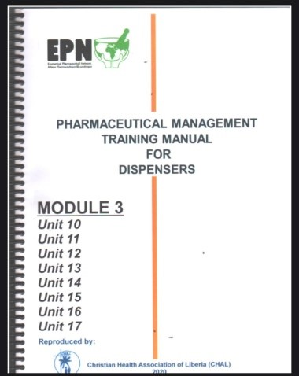
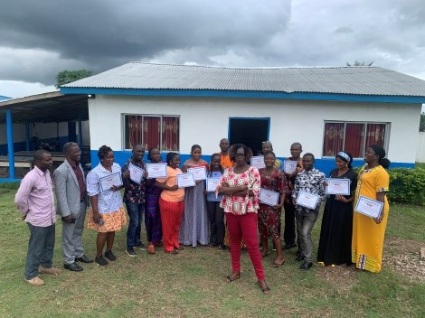
49 dispensers from 49 health facilities benefitted from a 6 week training course in Pharmaceutical management.

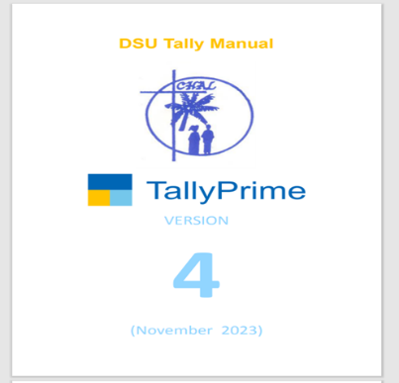
Established a suitable inventory keeping system Tally Prime for the DSU
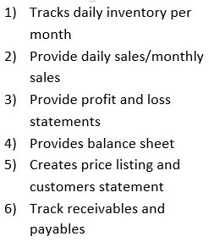
From January 2023 to December 5, 2023, CHAL has sold US$ 157,511.97 worth of medicines and medical supplies to 149 customers! All of her medications are from the Netherland(IMRES)

