aving Lives and Livelihoods (SLL) Project – Phase Two
Leave a Comment / By Chaliberia / October 27, 2025

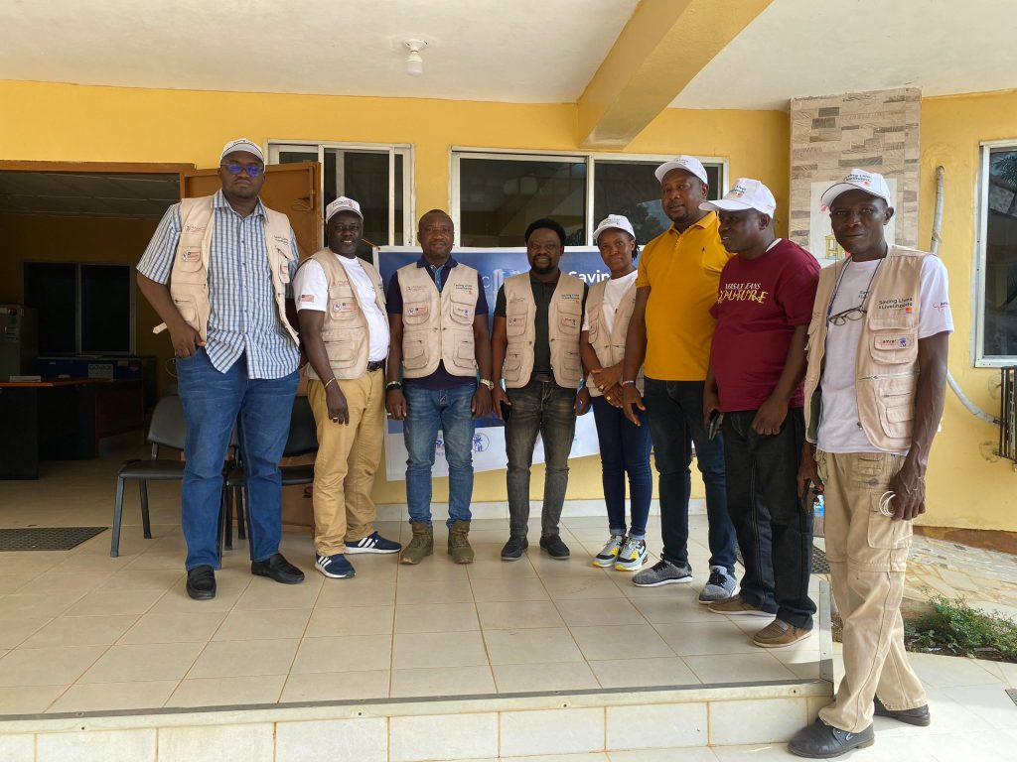
CHAL Advances Phase Two of the Saving Lives and Livelihoods (SLL) Project in Bomi, Grand Cape Mount, Gbarpolu and Grand Gedeh Counties.

The Christian Health Association of Liberia (CHAL) continues its remarkable journey under the Saving Lives and Livelihoods (SLL) Project – Phase Two, a continental initiative spearheaded by Amref Health Africa and the Africa Centres for Disease Control and Prevention (Africa CDC).
This phase focuses on deepening immunization coverage and strengthening health systems across Liberia — with particular attention to underserved communities in Bomi and Grand Cape Mount Counties. This project, which seeks to accelerate Africa’s COVID-19 vaccination and strengthen national immunization systems, remains a cornerstone in Liberia’s ongoing public health recovery and resilience-building efforts. The Phase Two implementation reaffirms CHAL’s commitment to ensuring that every person, no matter where they live, has access to life-saving immunization services.
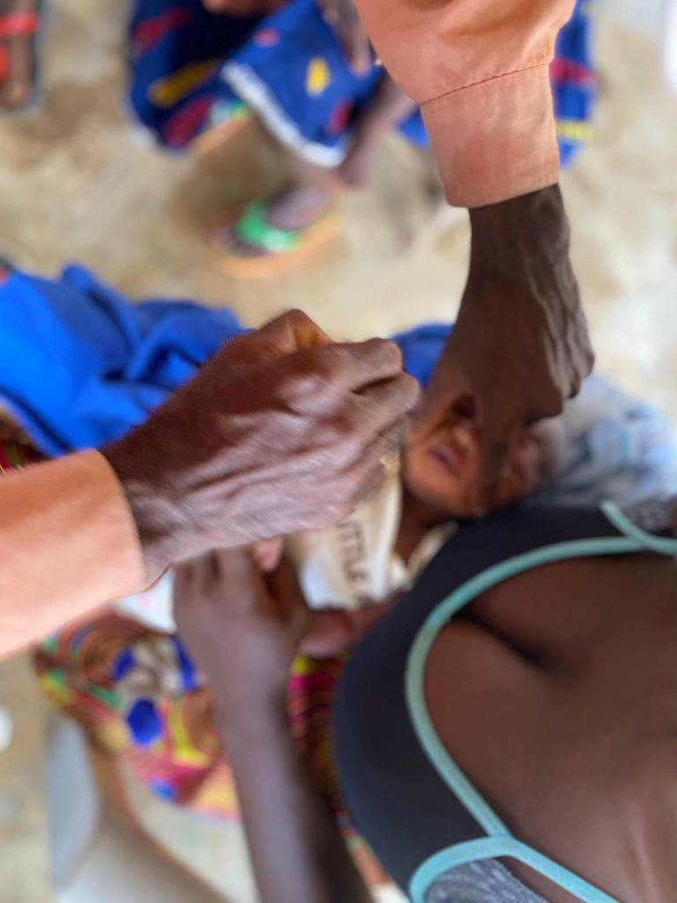
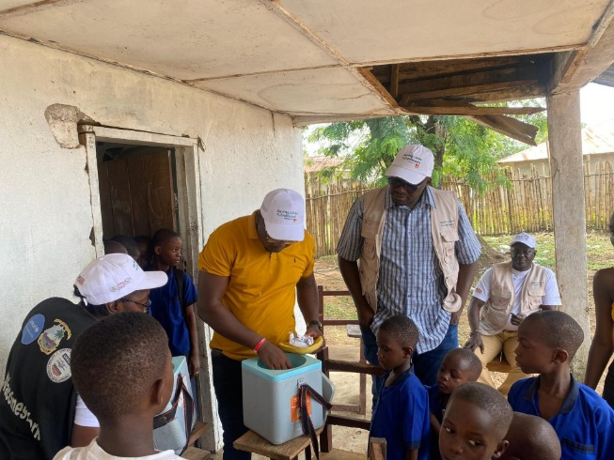
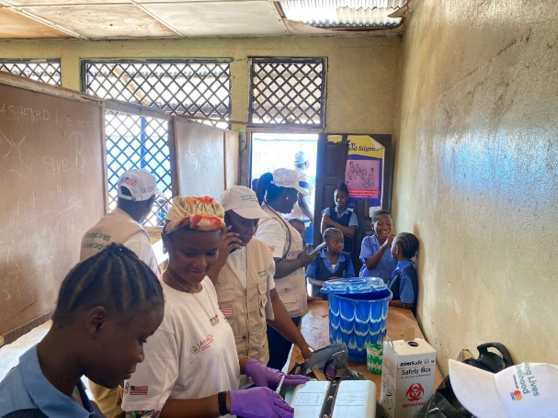
In partnership with the County Health Teams of Bomi and Grand Cape Mount Counties, CHAL has intensified vaccination drives and outreach activities targeting hard-to-reach and underserved populations.
Communities that were once distant from the health system’s reach are now actively participating in immunization efforts, thanks to coordinated mobilization and effective communication strategies.
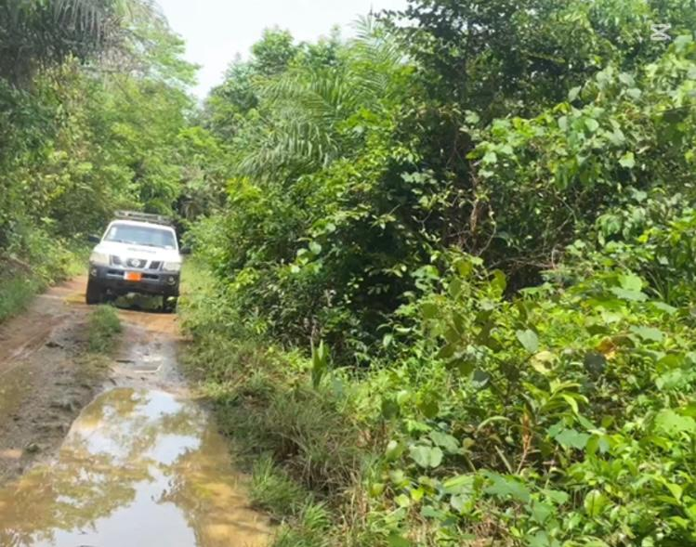
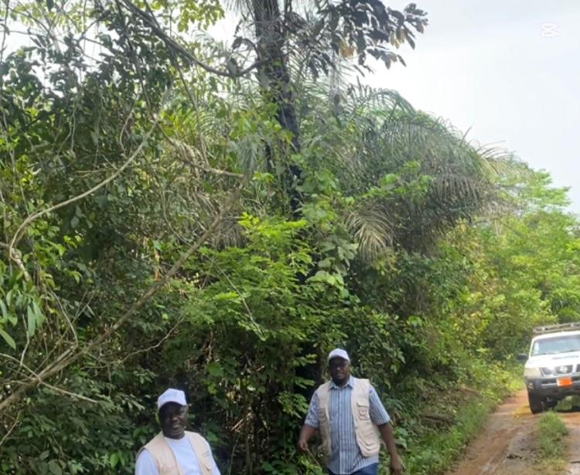
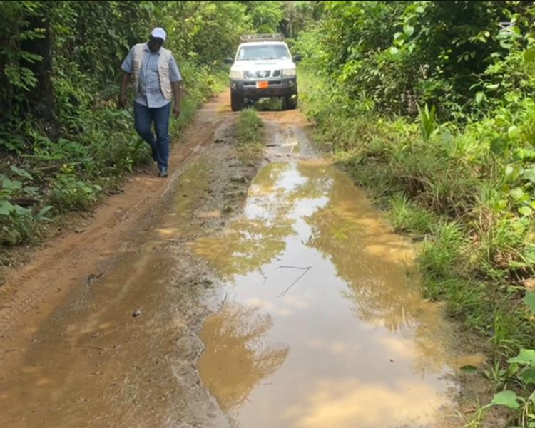
Health workers and volunteers continue to visit schools, marketplaces, and local gatherings, sensitizing residents on the importance of vaccination and addressing myths and misinformation that often hinder participation. The approach has not only boosted vaccine uptake but has also revived community trust in public health programs.

The journey to these communities often begins before dawn and stretches late into the evening. Teams navigate through unpaved roads, river crossings, and remote paths, traveling long distances before reaching a health facility or mobile outreach site. These logistical challenges mirror the daily realities of Liberia’s rural population, where accessing healthcare can mean walking several miles or relying on occasional outreach programs.
Despite these challenges, CHAL’s teams press on with determination, fueled by the belief that no distance should determine who gets to live a healthy life. Their perseverance symbolizes the heart of the SLL initiative — a commitment to leave no one behind.
A critical component of Phase Two has been the strengthening of health data management. In regions with poor or no internet connectivity, the process of data input and transmission presents a significant obstacle. However, CHAL’s field staff have employed creative solutions such as offline data entry and delayed synchronization, allowing accurate data capture even in the most remote settings.
These innovative approaches ensure that vaccination figures are recorded and reported promptly once connectivity is restored, contributing to national databases and enabling better decision-making. Through this, CHAL is not only supporting immediate immunization efforts but also enhancing Liberia’s digital health infrastructure and promoting a culture of evidence-based planning.
The impact of these activities is visible across communities. Mothers proudly display vaccination cards for their children, health workers express renewed motivation, and local leaders speak of fewer outbreaks and improved community health awareness. The project has created a ripple effect—improving health outcomes, strengthening livelihoods, and fostering a sense of ownership and collective responsibility for health at the community level.
Phase Two of the Saving Lives and Livelihoods Project continues to reinforce Liberia’s public health capacity through training, logistics support, and real-time monitoring. It demonstrates the power of partnerships between local and international organizations in achieving sustainable health impact.
By working hand in hand with Amref and Africa CDC, CHAL contributes to the broader African vision of self-reliant health systems capable of responding to emergencies and protecting populations against vaccine-preventable diseases.
As the project continues, one message remains clear:
“Immunization Saves Lives and Improves Health.”
It is not just a slogan — it is a promise to every Liberian child, mother, and family that their health and future matter.
